E-Training Best Practices in Business Environments
Monica M W Russell
University of Maryland University College
April 2014

Author Note
This paper was prepared for the University of Maryland University College Online Master of Distance Education Capstone Course taught by Stella Porto.
Abstract
This paper provides best practices combined with instructional design models to support workplace e-learning, identified as e-training in this paper. Increasing competition within the expanding global economy and the need to support rapid employee attainment of knowledge, skills and abilities is discussed as it relates to adult learning in the workplace. Challenges to e-training are examined and best practices are identified as responses to those challenges. E-training best practices are then defined and instructional design models are evaluated for their combined use in the successful implementation of e-training projects.
Keywords: e-training, e-learning, online learning, best practices, ADDIE, TPACK, SECTIONS, Kirkpatrick’s Four Levels of Evaluation

Dedication
This paper is dedicated to the memory of Fred West for his contribution and commitment to creating and supporting the formation of knowledge building blocks. Although he was not an educator in the standard definition of the word, he encouraged continuous learning and the importance of identifying how your ideas and strategies were supported, designed, framed and built. Fred was an active member of the Woodworking in America Association and supported WHYY, a Philadelphia based public broadcasting company. He passed away suddenly on January 11, 2014.

Introduction
In the world of work, the learning organization is fast becoming a key distinguishing feature of successful enterprises where accomplishments are measured by innovative learning that supports achieving business targets (Ketter, 2009). These targets may be external, such as gaining market share or they may be internal, such as reducing service center calls by improving customer interactions. In the October 2013 issue of the American Society for Training & Development magazine, T&D, the focus is on learning organizations that stand out for their organization’s learning achievements in the workplace learning arena. These organizations received the ASTD Best Award, a premier award that commends businesses that successfully tie employee training to business goals and objectives (Best Awards, 2013). A prevailing theme in each of the businesses highlighted is that learning in these environments is both strategic and tactical. Learning is strategic in that training is tied to business objectives and tactical in that the training supports and reinforces the business goals for a results-oriented approach to skill building and knowledge acquisition.
Being strategic and tactical are important characteristics for workplace learning where the focus is not on learning about, but on learning how and what to do and/or respond to people, situations, and change. Elaine Biech’s interview with Peter Senge (2008), who is known for his work with organizational development and the “convenient umbrella term,” learning organization, reinforces the idea that “organizations need to continually learn how—because it is key to their survival and ability to innovate, generative learning” (p. 649).
As businesses alter and modify their focus on becoming more innovative and being able to respond to changes in the global marketplace, adjustments can also be seen in internal organizational education. For example, face-to-face (f2f) training in a classroom environment where the instructor and the students are necessarily both present is now considered cost-prohibitive by some organizations (Kineo, n.d.). In addition, f2f classes by definition will take employees away from their work environments and place them in a shared space that may require travel for the instructor, travel for the students or travel for both. As businesses re-evaluate how and where they invest, travel is losing its appeal as a way to do business and certainly as a way for employees to connect. Email, instant messaging, webinars, and conference calls are taking the place of travel. In addition, where travel for training is required, managers and team leads may have to provide fill-ins for staff away at learning events, redirect work to other team members or accept that some tasks will be delayed. Because of the challenges with added expenditures, staffing, and completing job tasks and duties, work environments have shifted to learning that makes use of information and communications technology (ICT), is considered more efficient, is potentially a time and money saver and when tied to workplace performance and good design, can lead to “real productivity gains, tangible business improvement [emphasis in original] and a justified place in the organization of the future” (Hyland, 2010).
Interestingly, “appreciation for the benefits of technology-based learning has also grown, with e-learning accounting for more than one-third of formal learning hours available last year” (Miller, 2012). Waight & Stewart (2008), in their research case study involving companies who had e-learning in place for a minimum of four years, affirm that e-learning is no longer new or unique. Seraphim (2010), in the context of her study of a Greek bank, further explains what she describes as distance corporate training when she states that
Faced with the globalization of markets and an increasing domestic and international competition, most firms are coming to the conclusion that their survival depends on their capacity to maintain well trained employees that continually acquire new knowledge and skills, enabling thus the firm to respond rapidly to market opportunities and threats (p. 109).
This understanding of the banking marketplace, which is applicable to other industries where competition is no longer limited to physical borders, emphasizes the reality that global consumers are driving the economy and companies are using technology to support learning that can be transformative (Mimicopoulos, n.d.; Seraphim, 2010; Phillips, 2007; Schomberg & Milliken, 2013). This author would explain transformative to mean a changing recognition of assumptions and beliefs about the corporate learning landscape. This recognition has the potential to develop into understanding the importance of responding quickly to a competitive and fast-paced global business environment where e-learning can be a supportive method for transferring knowledge, skills and abilities.
Because e-learning is seen as one response to global competition and the need to keep up with change through training, many organizations are growing their e-learning opportunities. This method of workplace training continues to grow in popularity as a way to support learning in corporations, small and medium-sized businesses and even as a way to support employees in mom-and-pop shops (Jia, Wang, Ran, Yang, et. al, 2011; Berge, 2001; Biech, 2008; Paulsen, 2009). However, just because e-learning is in use, does not mean that it is useful to the organization. According to Jia, et. al., “most workplace e-learning applications fail to meet learners’ needs and ultimately fail to serve organization’s quests for success (2011, p. 3372). Brown & Charlier (2013) reinforce the idea that “the availability of an e-learning resource does not ensure its use, let alone its effectiveness as a tool to change employee behavior” (p. 37).
This paper seeks to identify strategies and best practices that will provide support for organizations implementing workplace e-learning. With the widespread use of e-learning approaches in various industries and the reality that ICT-based workplace training may not meet the needs of the organizations that employ this method, applying the right models, processes and theories may mitigate the challenges associated with corporate elearning and potentially provide a blueprint for corporate elearning projects.
Literature Review
Because the goal of this paper is to identify best practices that incorporate technology to support workplace learning and to deliver training and instruction, strictly face-to-face corporate courses in brick and mortar environments will not be addressed. Information on ICT-based workplace learning can be found in journal articles, online magazine articles, news websites, case studies, industry books that are compilations of articles from various industry leaders, books written by one or more authors that address this topic and white papers to name a few of the resources that will be used in the literature review. We will begin by looking at adult learners who comprise the audience for ICT-based workplace learning, continue with an examination of terminology, and conclude the literature review with a discussion of challenges in workplace environments that may impact workplace learning delivered via technologies.
The following list provides an overview of the areas that will be discussed:
- Examines adult learners in business environments
- Defines e-training
- Discusses why e-training and not e-learning, and
- Evaluates workplace challenges
  - Economics and the business impact
  - The importance of good instructional design
  - The value in feedback and support
  - Challenges with technology
  - Understanding audience diversity
  - Change management and organizational culture
Adult Learners in Business Environments
As part of the discussion of workplace learning, the adult learner must be analyzed. Malcolm Knowles, an adult educator, cemented the use of the term andragogy or the study and science of how men (later generalized to adults) learn. In the American Society for Training and Development Handbook (1996), Knowles provides a chapter on adult learning where he defines six assumptions about adult learning. Those six assumptions and their corollaries are paraphrased below:
- Adults want to know:
  - why learning needs to happen
  - how learning can help them
  - if the learning opportunity can be ignored because it is not relevant enough to merit their time and attention
- Adults desire to direct their own paths because once adults have made the transition to being responsible for self, learning becomes a personal responsibility as well
- Adults bring their experiences, understanding and perspective into the learning environment, thus adults
  - are not clean slates to be written upon
  - want their experience and knowledge to be respected in the learning environment
- Adult readiness to learn is internal and may need to be coached out of them by
  - using real world simulations
  - highlighting others with more experience or
  - showing the potential value of the learning opportunity to their specific situation
- Adults are task-oriented and problem-centered and need to know how they can apply and use what they will be learning
- Adults are motivated to learn both essential and nonessential information and
  - may respond well to learning that clearly ties together how it will support work responsibilities and how the learning may benefit them personally
  - may not be motivated to learn if the benefits of the learning are not clearly spelled out (Knowles, 1996).
The aforementioned characteristics of adult learners help to clarify their expectations for learning in the workplace. Adult learners are not going to embrace learning opportunities that have unclear objectives, do not offer an explanation as to how the course or information can personally benefit them, and/or cannot be applied to job responsibilities and tasks. DiLello & Vaast (2003) discuss adult learning theory and its impact on businesses in an article in the Chief Learning Officer magazine. This is a short article with a few main points that can also be used to emphasize the uniqueness of adult learning and reinforce

Knowles’ (1996) definition of adult learning. The main points of the DiLello & Vaast (2003) article are that:
- Adults prefer problem-centered training instead of content-centered training and
- Adults want to learn about topics that are directly applicable to their jobs and personal lives.
When discussing adult learners in business and corporate environments then, the emphasis should be on the connection between the topics presented and business goals, company initiatives and personal growth. This focus has the potential to address a critical area of concern, namely the need to know why the training is important and how it is relevant. Adult learning in a work context, however, is not limited to the need to know. By contrast, workplace learning should also provide problem-centered training opportunities that take into consideration readiness to learn, the use of personal experiences to make sense of new information, and allow for self-direction where possible.
Defining E-Training
Although, e-learning has been used to characterize workplace learning that makes use of ICT, this author proposes the use of the term e-training to describe the type of training and learning that originates in the workplace and is made available to employees using information and communications technology (ICT) instead of classrooms and onsite teachers and students (Waight & Stewart, 2005; Rosenberg, 2006; Rabak & Cleveland-Innes, 2006; Bullen & Janes, 2007).
Why the term training and not learning or education or instruction? According to Berge (1998), “education broadens understanding by persons to problem solving outside existing models and to ill-defined systems of knowledge” (Berge, 1998, p. 20). Training, on the other hand, uses a person’s current understanding for skill building and education responds outside of what is known and understood to address issues (Berge, 1998). For a more current definition, Rosenberg (2001) uses training and instruction interchangeably and writes that “training/instruction is used when it is necessary to shape learning in a specific direction—to support learners in acquiring a new skill or to utilize knowledge in a specific way or to a specific level of proficiency, and perhaps within a specific time frame” (p. 5).
Rosenberg (2001) further advises that training has four components:
- “Intent” where training is scaffolded with learning needs, “goals and instructional objectives,”
- “Design” where training is based on learner needs, the best way to communicate the instruction and some method for confirming that learning has occurred,
- “Means and media” where training is disseminated using the most appropriate technology or technologies and may be conducted in a classroom and not limited to technology vehicles, and
- “Assessment” where training outcomes are evaluated for “high accountability situations” or certifications (p. 5).
Stolovitch & Keeps (2002) further demarcate the discussion by defining training, instruction, education and learning as individual and separate entities. Training, in a sense, is creating a repeatable habit while instruction allows for adjustments to be made as needed when responding to situations (Stolovitch & Keeps, 2002). Education is not viewed by Stolovitch & Keeps (2002) as something that happens in a classroom or online, but is more of a response to information that instructs using experience and events to create meaning. In their final definition, Stolovitch & Keeps (2002) succinctly state that “learning is change” and they conclude their discussion of definitions by asserting that
if we train—the general term commonly used in the work setting for all three sets of activities—we do not simply transmit information. We change people. We transform our learners in ways that are desirable both for them and for our organization (p. 13).
Though it is possible to concede that the individual definitions from Stolovitch & Keeps (2002) are reliable albeit limiting, the act of training remains a term uniquely suited to what happens in a business organization and not the wider academic arena.
By returning to the accepted definitions for each term, we can strengthen the argument for e-training in work environments. Using the Google define: functionality, the definitions for each term are below:
Table 1
Common Terms for Learning and Teaching Defined
Term | Definition
Education | “the process of receiving or giving systematic instruction, esp. at a school or university” (Define Education, n.d.)
Learning | “the acquisition of knowledge or skills through experience, study, or by being taught” (Define Learning, n.d.)
Instruction | “a direction or order” and “detailed information telling how something should be done, operated, or assembled” (Define Instruction, n.d.)
Training | “the action of teaching a person or animal a particular skill or type of behavior” (Define Training, n.d.).

The idea of education is tied to systematic instruction where there is the expectation that there will be a series of courses that will build upon each other and culminate in a final course that validates understanding of the topic or idea. Learning can be formal or informal; it can be relevant to work, personal experience, relationships, skill building and so forth. Learning does not automatically confer the idea of workplace learning where how to perform a task or address a problem is expected. Instruction is very similar to training, but includes the view that instruction may be a command and not simply showing how to perform a task or complete an assignment. Training, then, is specifically focused on teaching both skills and behaviors. This is distinctively suited to the idea of workplace learning where the goal is to teach skills and behaviors that support the employee which in turn is expected to support the business. The ‘e’ in e-training is the addition of ICT or an electronic method of sharing and communicating the learning opportunities, materials and assessments.

Why E-Training and Not E-Learning?
Paulsen (2009) identifies a list of e-training advantages based on case studies that explain how e-training in business environments can potentially lead to:
- Improved flexibility in time and location
- Reduced costs for travel, accommodation and seminar rooms
- Swifter and cheaper distribution of learning material
- Quick introduction of new products due to accelerated training of many employees
- Increased sales because customers perceive e-learning as a sign of high competence and added value to the product
- Improved relations with customers and suppliers
- Positive organizational effects.
From this author’s perspective, there are several additional factors of e-training that are also important. One factor is that ICT opens the door to potentially interactive learning opportunities that can occur without the employee and the instructor being in the same place at the same time. E-training can be in the form of online courses or online modules, computer-based learning that can be put on a CD or stick drive, web-based training that can be accessed via an Internet connection, simulations, games, digitized live presentations, job aids that are accessible via Internet or mobile devices, short video lessons on topics relevant to work or an employee’s position in an organization, and regulatory and compliance training that may also be available online, via Internet, or mobile devices (Harun, 2002; Tsai & Machado, 2002; Olafsen & Cetindamar, 2005; Brown & Charlier, 2013). This list does not encompass all electronic training, but provides examples of some of the types of e-training that may be available in business organizations.
Another unique aspect of e-training is that learning is relevant to the business and either tightly or loosely tied to business goals or company initiatives (Kok, 2013; Kuhlmann, 2012; Jia, Wang, Ran, Yang, et. al., 2011; Hyland, 2010). For example, if a business goal is communication, then the e-training promotes communication between teams within the organization or improving communication skills for customer interactions. Another example is if the e-training supports a company initiative to gather more business from a particular sector of the marketplace where the learning opportunity focuses on understanding that area of the marketplace, the competition and what the goals are for the future customers in that area.
A third and final element of e-training that makes it unique is that e-training may be instructor-led in a synchronous environment, but can still be instructor-led using voice over in asynchronous environments. Instructors may not be available at the moment that learning is taking place, but employees can have multiple methods for contacting the instructor or content owner if needed.
In conclusion, there are several distinguishing factors that make e-training excellent terminology for corporate e-learning. These distinguishing factors are that e-training is:
- Tied to business goals and/or company initiatives,
- Specifically geared toward employees within a business organization and not adults in general, and
- Can be accessed using the Internet, mobile devices or any other technology that is not tied to time and place.
The differentiating elements discussed above reinforce the use of the term e-training because of the focus on business-related concerns. Skill building, task application, and acknowledging the relevance of the business organization’s goals supply the foundation for learning that supports employees within that context. The purpose of workplace training, therefore, is not to expand knowledge for the sake of knowledge, but to build skills that can tie-in to organizational goals and possibly mitigate business challenges. In addition, the current environment calls for workplace training to be available when and where the employee needs it thus the support for electronic or e-training. E-training falls under the umbrella of e-learning, but the audience for e-training consists specifically of employees in business environments. Moore & Kearsley (2012) further support this definition by explaining that “training is regarded as a domain within the general universe of education, usually aimed at learning practical skills” and in business no matter the challenge, the goal will be to learn skills that can be applied to the job, business, and bottom line (p. 2).
Workplace Challenges
There are local in-house challenges to e-training that happen in various businesses every day. These are challenges that include, but are not limited to, a lack of support from upper management, difficulty gaining buy-in for new ways of learning and finding ways to create relevant and interactive training that keeps the attention of employees who are bombarded by emails, instant messages and work-related tasks that compete for attention. Bates & Poole (2003) provide another workplace challenge when they explain that “the biggest change in developed countries has been the reduction in the need for large numbers of unskilled or semiskilled manual workers to operate factories and industrial production lines” (p. 13). Bates & Poole (2003) argue that this particular change has resulted in the need for workers in technology and service sectors. Both of which require skilled workers who can learn as fast as change occurs in these industries. Although Bates & Poole (2003) primarily reference higher education, their observations are relevant to e-training in corporate environments when they say,
Many of these new industries require a much greater proportion of highly educated workers, and furthermore require a highly flexible and adaptable workforce that can continually change as the world changes around them. Thus the new knowledge-based industries, in order to compete effectively, require not only up-to-date and recent knowledge, but also workers who are constantly learning (p. 13).
Companies are beginning to appreciate e-training as a way to support constant learning while “becoming more competitive, effective, efficient, and agile” (Miller, 2013, p.6). In 2011 there were economic challenges and face-to-face instruction was still the primary method of corporate training based on the respondents for the 2011 ASTD State of the Industry Report (Green, 2011). According to the 2013 ASTD State of the Industry Report, one-third of the formal learning made available last year was made available as e-learning (Miller, 2013). The reason for this is three-fold: organizations want learning to spread-out and reach employees no matter where they are located, companies are committed to promoting the development of new abilities that will help them respond to a changing landscape and businesses want to do all of these things reasonably priced (Miller, 2013). The issue, however, is that e-training does not always achieve the anticipated goals that businesses have in mind when they implement e-training initiatives and projects.
The Need for Engaging Instructional Design
Instructional design is a foundational issue when adopting e-learning in higher education and this is no less true for businesses that choose to include e-training as a part of their education strategy. Creating training that is engaging and interactive, challenging yet informative and real-world while being convenient only scratches the surface of what employees need when their learning opportunities are facilitated by technology.
Many of the more recent case studies do not spend a lot of time on instructional design. Businesses that have adopted or are adopting e-training are more prevalent and the use of e-training continues to grow (Miller, 2013; Green, 2011). Thus, whether or not e-training is designed well does not have the same emphasis that it did when e-learning was considered new and becoming popular in both the higher education arena and corporate environments (Holmberg, 2005; Bates & Poole, 2003; Rosenberg, 2001). Just as business is evolving, the e-training focus is also expanding to include:
- the learner as an integral contributor to the learning process,
- training strategies that support workplace initiatives,
- knowledge management,
- performance support,
- needs assessments,
- selecting face-to-face training where appropriate for the learner and the material to be taught,
- using technology wisely,
- evaluating training and the business impact, and
- moving from the didactic method of instruction to one that provides more support and guidance than commanding and controlling (Rosenberg, 2006; Biech, 2008, Mosher, 2013).
Instructional design remains an important consideration, but it is part of a wider business view when speaking of e-training. However, in order for e-training to be successful, instructional design must be included as a workplace challenge because without design, instruction is limited to lists of objectives driven by business units whose end goal does not include what is relevant to the adult learner. It is important that a balance is achieved by addressing the tension between designing programs, courses, modules, job aids, and learning activities while at the same time meeting and possibly exceeding the needs of the business while mitigating concerns about the bottom line. Instructional design addresses both the requirements of a learning opportunity as it relates to business goals and objectives and the methods that will lead to effective learning for the employee audience (Stolovitch & Keeps, 2008, Sink, 2008, Herrmann-Nehdi, 2008).
The Lack of Use and the Importance of Intervention
In Brown & Charlier’s (2013) view, lack of use is a notable concern with e-training. The primary issue is that the increased adoption and use of e-training by businesses will not automatically lead to successful outcomes if employees do not utilize their e-training opportunities. Lack of use can be mitigated by relevant intervention where the employee receives assistance or support when they need it, motivational intervention where business goals tie in to e-training content, and by incorporating employee feedback (Brown & Charlier, 2013). Engaging the learner with effective instructional design and intervening before, during and after e-training are important strategies to consider when discussing e-training.
The word, intervene, has multiple definitions. For the purposes of this discussion, to intervene is “to become involved in something (such as a conflict) in order to have an influence on what happens” (Merriam-Webster Dictionary: Intervene, 2014). The definition uses conflict as an example, but intervention can also be applied to different stages in a process where one desires to have an influence on what happens in that part of the process. For example, intervention that occurs before e-training has begun can come in the form of tutorials-in-print and advance organizers. As an instructor or course designer, the desire is to prepare the training audience for the information, tasks, and ideas that they will shortly be exposed to for the purposes of the training. Although interactions during a course and feedback during and after a course are important, creating learning opportunities that are welcoming and not off-putting before a course even begins are central to the issue of lack of use.
The tutorial-in-print supports and potentially engages the learner because tutorials-in-print are conversational guides on paper that should give the impression that the information is directed to one individual learner prior to having the learner interact with the learning material (Holmberg, 2005; Rowntree, 1990). Questions can be a part of tutorials-in-print where students are asked to read and identify x number of parts to a process or y number of ways that one could approach a problem. Advance organizers also have the potential to engage the learner. Designed by David Ausubel, “Advance Organizers [author’s emphasis] are a model for helping students organize information by connecting it to a larger cognitive structure that reflects the organization of the discipline itself” (Kirkman & Shaw, 1997, p. 3). This is potentially a fundamental component of engaging students because an advance organizer can put topics in their proper context and allow workplace students to begin interacting with the content before they even begin their e-training. In addition,
advance organizers are not the same as summaries or overviews, which comprise text at the same level of abstraction as the material to be
learned, but rather are designed to bridge the gap between what the
learner already knows and what he needs to know before he can
successfully learn the task at hand. (Ausubel, 1968, p. 148)
Advance organizers allow you to plan ahead and tutorials-in-print “design the dialogue into the content” so that employees can engage with the material before e-training begins (Kirkman & Shawn, 1997; Peters, Holmberg & Moore, 2008).
The interventions discussed above occur before course delivery and are not exhaustive nor do they address every stage in the e-training journey. Student support can and should also occur during the course with additional assistance provided after e-training if it is determined that a need is there. Advance organizers and tutorials-in-print are, however, uniquely important for adult learning in the corporate context because adults need immediate relevance and both methods have the potential to create the necessary connections that can facilitate identifying with the course materials and determining both the professional and possibly, personal benefit early in the learning process. As Smith & Drago (2004) explain, “on the employee side, organizations can no longer count on the loyalty of employees to dedicate themselves to training, particularly if that commitment extends to learning on their own time” (p. 194). In the current marketplace, employers may not explicitly tell their employees to get their training completed during their off hours, but circumstances may necessitate working past the workday and connecting employees to content in a way that motivates the desire to find out more is an important part of the e-training process.
Technology for the Sake of Technology
Another concern with e-training is the adoption of various technologies for e-training without solid evaluation because the technologies are popular or currently in use. Although this paper is focused on the business side of e-learning, Bates & Poole (2003) argued against the same issue with respect to education in general when they stated that “another recurrent feature of the development of educational technology has been an unwarranted optimism by business and government that each new technology would be a panacea for all the shortcomings of the education system” (p. 8). Technology for the sake of technology can create more problems than the use of technology for training solves. Jia, Wang, Ran, & Yang, et. al (2011) introduce the reader to their concerns early on when they explain that e-learning development puts too much emphasis on the technical and not enough on business and the method and practice of teaching employees. They go on to remind us that “the dominance of technology-oriented approaches makes e-learning systems less goal-effective, and makes them perceived as being poor in quality and design accordingly” (Jia, Wang, Ran, & Yang, et. Al, 2011, p. 3372). To address the issue of employing technology for technology’s sake, its use needs to align with learning objectives and should support the successful delivery of content (Moore & Kearsley, 2012). Selecting technology based on learning objectives carries with it the unspoken expectation that learning objectives are tied to business goals and initiatives when discussed within the context of e-training or corporate e-learning.
Audience Diversity
An added workplace challenge with e-training is the reality that the workplace may have as many as four generations working at the same time (Zaporzan, 2010). In addition to possible generational conflict, there is a divide amongst technology users where some embrace technology and others abhor the same. Interestingly, comfort with technology may cross boundaries and is not limited to the employee’s actual generation (Barnes, 2013). However, it is still possible to cluster employees based on their response to technology. These groups can be identified as digital natives, savvy technologists, reluctant users, digital contrarians and digital newbies to name a few (Dobrin, 2012). Each of the classifications above are taken from an infographic related to how to train end users on the use of social media (see http://www.mindflash.com/blog/2012/03/infographic-how-to-train-your-employees-to-handle-your-social-media/). Although Dobrin (2012), the author of the infographic, is focused on training specifically for social media, the descriptions can be considered applicable to the wider training audience especially if the focus is on those who are new to technology, those who are open to interacting with technology and those who are against the use of technology. These three types are common in the field of healthcare where new clinicians and physicians are being exposed to technology in medical school so the use of technology for training is not foreign and may even be welcome. Whereas clinicians and physicians who have been working for several decades in the healthcare arena are apt to pawn off any tasks that involve computer-aided technology to those in their department who interact with technology on a more regular basis. What does this mean for e-training? In many workplace environments, e-training takes away the option to avoid learning opportunities that make use of ICT and this forces instructional designers and course teams to create training that is effective for both savvy technology users and those who would rather face-to-face or paper-based learning. It is essential to note that e-training is not a panacea for an employee’s response to technology or to the various workplace challenges identified up to this point. It is, however, possible for well-designed e-training to address the needs of workplace learners while taking into consideration those issues that present roadblocks to the learning experience. This is where understanding how different people may react to technology is an important deliberation.
How employees respond to learning that incorporates technology is one concern when creating training for a diverse audience, but as mentioned earlier there are also potential generational challenges. Zaporzan (2010) identified four generations, but Gravett & Throckmorton (2007) identify five generations. Where both converge is the importance of acknowledging the difference among the various generations and finding ways to bridge those differences. Gravett & Throckmorton (2007) explain that whether or not the various generations get along will have an impact on profitability, however, this author proposes that generational harmony or the lack thereof also has the potential to impact e-training. For example, baby boomers may want to be able to select a linear training path while GenX employees might want a non-linear training path and GenY employees could desire a training path that allows for picking and choosing based on their current needs. Creating e-training that allows for self-direction is one way to meet this need where both linear and non-linear paths are provided along with job aids and chunked learning on key topics that are relevant to all. Audience diversity is not limited to demographics and can include generations with shared experiences and expectations along with adult learners who respond differently to the use of technology in training.
Change Management & Organizational Culture
Change management and corporate culture are identified as workplace challenges because they are two potential obstacles to e-training success. If change initiatives are not evaluated within the framework of change management and assessed based on current corporate culture, adoption of new ways of looking at learning may be ignored, pushed back or sabotaged at the extreme end. Recognizing that both unseen and observable corporate culture will impact any initiative is necessary if new ideas are to get buy-in. Gauging the impact and response of new initiatives within the context of change management is another way to prepare for resistance even if there ends up being none. Even actions as minor as recognizing the impact of word choice and the opportunities that formal and informal conversations present may help to create a more positive and receptive atmosphere before e-training is even begun.
Al-Abri & Al-Hashmi (2007), in their discussion of The Learning Organization and Health Care Education, put forth the idea that “one of the biggest challenges that must be overcome is to identify and breakdown the ways people reason defensively” (p. 10). They go on to explain how crucial it is to recognize that personal choices in how employees respond to problems can be problematic to the organization and should be addressed (Al-Abri & Al-Hashmi, 2007). Although an instructional designer or course team may not identify e-training as a problem, those in the organization who do might negatively impact the corporate culture and create roadblocks for change.
For a deeper dive into change management and organizational culture, the American Society for Training & Development (ASTD) Handbook for Workplace Learning Professionals (2008) was consulted. The handbook provides an entire section on the importance of understanding and addressing change management and cultural change. McLagan’s, Leading Complex Change, and Haneberg’s, Organizational Culture, were used to gain a better understanding of the impact of change and culture on e-training in business environments. The majority of the literature briefly recognizes the importance of change management, but does not delve deeply into this area of concern while corporate culture is rarely addressed in a way that clearly defines cultural issues. Newton & Doonga (2007), in their justification for the importance of evaluation, add one sentence about “employing employee morale, employee retention, impact on customers and impact on corporate culture” (p. 122). There is not a detailed discussion of change management or cultural change nor are there references to the impact that a negative culture or a mismanaged change experience might have. Seraphim (2010) also includes a note about culture in the literature review section of her article, but does not address this as a separate issue in the article’s study findings. Although, taking a cue from Berge & Kendrick (2005), Seraphim (2010) does briefly explain that a lack of cultural support can destroy e-training initiatives even with excellent technology and adequate funding.
The success of an organization lies in its ability to effectively manage change and to marry business goals to the corporate culture. McLagan (2008) provides guidelines for successful change initiatives. She proposes that change must be evaluated in the same manner as other business initiatives, technology purchases, and current and new processes. Just as it is important not to choose a technological learning path for the sake of technology, it is also important not to implement change for the sake of change (McLagan, 2008). Once change has been evaluated and it is determined whether or not the change is transactional, transitional or transformational, it is then time to strategize, implement and support the change. As McLagan (2008) concisely explains “thinking that a communication from the president or a training program will suffice, as it does for a transactional change” will not work for change that requires changes in job responsibilities or activities and it certainly will not be enough to motivate change if the change is transformational (p. 636).
An Example of Change Management in the Healthcare arena.
In the healthcare arena, there are hospitals, community health systems, large academic medical environments, and rural healthcare clinics which may be either non-profits or for-profit healthcare entities. Where the healthcare environment becomes connected to the wider business landscape is that e-training is pervasive. Because of the 2011 electronic health record (EHR) initiative that provided incentives for healthcare environments to meaningfully adopt and use electronic health systems, even small clinics and physician offices are implementing some form of electronic medical records. This transition from paper to electronic has mirrored a shift from classroom to online learning. The move to various electronic teaching methods opened the door to virtual and simulated training in the surgical area as one example. The increasing use of Healthstream, an online compliance and medical training provider that supports both large organizations that decide to outsource training and smaller organizations that do not have the financial resources to create in-house compliance training, is another example of the prevalent use of e-training in healthcare (Healthstream, 2013: Academy of Medical-Surgical Nurses, 2013). Precyse Solutions, as another example, celebrated their partnership with Healthstream in 2011 (Precyse Solutions, LLC, 2011). This was considered a major milestone for the company even though Precyse University is a fully accredited online learning portal that offers continuing education units as a part of its portfolio (Precyse Solutions, LLC, 2011). Because the use of Healthstream’s e-training learning management system and their learning content is so widespread in the industry, other healthcare organizations offering e-training still want to partner with Healthstream as a way to meet the needs of current and future customers who desire one learning portal.
In the rapidly changing healthcare environment, Harun (2002) offers an explanation as to why healthcare is unique in the e-training conversation:
As in all types of working environments, but especially more so in the medical and healthcare environment where being complacent, negligent, and out-of-date with work-related advances could make the difference between life or death outcomes in patients, there is a constant need to rapidly train and retrain the workforce in new technologies, products and services found within the workplace setting (p. 305).
This “constant need to rapidly train and retrain” is the cornerstone of the healthcare industry (Harun, 2005, p. 305). It is an environment where change is constant and may be rapid or deadline-focused. For example, mad cow disease prompted an immediate change in World Health Organization (WHO) standards for sterilizing surgical equipment, but the transition to the International Statistical Classification of Diseases and Related Health Problems (ICD) coding system has a deadline that has been pushed back for over two years and was recently delayed again (Rubenstein, 2009; Bresnick, 2014). Thus, change in the healthcare environment not only requires a workforce that can adapt to change, but also necessitates training that can quickly get healthcare professionals up-to-speed and proficient in new processes, responsibilities, technologies, roles and tasks.
To further clarify change, McLagan (2008) provides definitions of different types of changes. Transactional change is one type of change and is the type of change that is inevitable and/or simple in that the change itself does not require a lot of effort. For example, software upgrades that eliminate bugs without offering significant functionality updates or moving from using one type of laptop to another type of laptop where both have the same operating system could be considered transactional changes.
“Transitional changes involve multiple shifts and role changes where others have paved the way to success” (McLagan, 2008, p. 635). For example, moving from a Windows machine to an Apple product might be considered more of a transitional change because how the employee interfaces with the computer will be different, but companies have made this type of change before and others can learn from those experiences. Transformational change, on the other hand, can be complex and is the type of change where there are no blueprints, frameworks or guidelines on how to proceed (McLagan, 2008). Implementing e-training, therefore, can have a different impact on different environments and will need different change management approaches depending on the type of e-training that is being introduced and the circumstances surrounding the business requirements. A few examples are described in the table below:

Table 2
Examples of Different Types of Change with Healthcare Illustrations
Type of Change | Scenario | Scenario Description | Potential  Impact | Possible  Responses
Transitional | New policy on hand washing before surgery. | Roles and tasks are not changing. Hand washing before surgery is currently a requirement, however the type of soap used has changed and the length of time for washing has been extended. | Minimal | - Required compliance training  - Posting Job Aids where hand washing occurs  - Global email communication to alert all staff to the change  - Verbal communication from department heads  - Short e-training course on why the change and how the change benefits the employee.
Transactional | Transcription software update with new functionality that replaces the old. The role of the transcriptionist changes to that of medical editor. | A new transcription system will be implemented that removes the need for transcriptionists. Anyone who currently listens to physician dictations will no longer need to type every word; they will instead become medical editors with new job responsibilities and different metrics for compensation. This is not new and other hospitals have had successful transitions when transcriptionists have had to become medical editors. | Moderate to High | - Global email communication to alert all staff to the change  - Department specific email to explain how the changes will impact the Transcription department  - Verbal communication from department heads  - E-training on how to use the new software  - E-raining on how work will be measured  - Job Aids for the most frequently used functionality  - Scenario-based e-training that makes use of positive transition experiences at other healthcare institutions
Transformational | The medical coder role is being eliminated and currently there are not any other hospitals or healthcare facilities that have implemented software that removes the need for a medical coder and the medical coding position. | Medical coders become unnecessary. Patients can identify their own ailments using tablets or kiosks and based on physician recommendations, the software will determine if the codes are accurate or need adjustments. As a example, if a patient says that they are dehydrated and they are on 150 ml of IV fluid per hour then their treatment confirms dehydration and that information can be pulled from the patient’s electronic medical record and evaluated by the new system. If the patient is receiving 50 ml of IV fluid per hour then the patient’s claim of dehydration is not supported. | High | - Leadership implements a pilot for one low-use area of their hospital, e.g. not the Emergency Department or Inpatient surgery, but possibly physical therapy which is not 24/7. This pilot is evaluated for ideas about how to introduce the software and the changes to the organization. This would be one step in a multi-pronged project and cannot be easily addressed as there are no best practices for a change that has not yet been implemented to the best of anyone’s knowledge.

The above table is based on McLagan (2008) and provides examples of possible changes illustrated with healthcare scenarios and how instructional designers or course teams might address the change management challenge. These are the author’s ideas and are based on potential real life scenarios.
Whether change is transactional, transitional or transformational, organizations need to be able to respond to change in a way that encourages acceptance of the requirement for change. In the examples in the table, each change requires educating the workforce. Using e-training to meet that need can be effective if change is managed and the culture either is accepting of the change or can be brought to acceptance of the change. Specifically, from a change management/change leadership perspective, the main ingredients for the successful implementation of e-training opportunities are:
- Responding to resistance based on the situation and the level of resistance by using “situation-appropriate change methods,”
- Reflecting on the change from the beginning of the change process to the end of the process while identifying the impact that the change is having, the response to the change effort, and any resistance to the change.
- Educating the masses on change management and making change leadership the business of every department, team, manager, and individual (McLagan, 2008).
Corporate culture is the other issue in organizations that should be addressed in conjunction with change management. Even if change is well-managed, a culture that rejects change can create larger challenges that change management may not be able to address. Corporate culture is driven by conversation (Haneberg, 2008). Because conversation is the driving factor, e-training initiatives will need a vocabulary that supports their adoption, management and team leaders who speak well of the initiatives, workplace learning professionals who exemplify the culture that they want to create and who reinforce the creation of that culture with their conversations (Haneberg, 2008). In addition to providing questions for support with leading change in corporate culture, Haneberg (2008) explains the importance of conversation in her description of leadership, “It is through conversations—talk, observed actions, listening, writing—that leaders manage, reinforce, and create culture. Leadership is a social act and a leader’s greatest tool for shaping culture is the conversation” (p. 628).
Understanding the value of directed conversation is another technique that should be used when attempting to implement e-training solutions in today’s marketplace. Even if the first e-training course focuses on understanding the business environment or another topic that is popular and would be well-received, the approaches used will either support or undermine the e-training structure. The same holds true for conversation. If learning leaders use vocabulary that is disparaging instead of vocabulary that encourages acceptance and communication, e-training does not stand a chance. Thus, paying attention to what is said, how e-training is described, the verbal response to e-training initiatives and the communication around the water cooler all have the potential to create changes in perspective, understanding, and support.
Analysis
Best Practices
What are best practices? Baghdadi (2011) suggests that the meaning of the term, best practices, does not have universal consensus. However, he still makes an effort to explain best practices by providing his own definition: “the best practice in education is the most efficient (least amount of effort) and effective (best results) way by which society transmits its accumulated knowledge and skills from one generation to another” (Baghdadi, 2011, p. 109). A google search for best practices yields the following result; “commercial or professional procedures that are accepted or prescribed as being correct or most-effective” (Define Best Practices, n.d.). Also, businessdictionary.com offers this definition: “A method or technique that has consistently shown results superior to those achieved with other means, and that is used as a benchmark. See also best in class and leading practice” (Define Best Practices, 2014). Interestingly, the business dictionary, as previously quoted, provides two additional synonyms for best practices, “best in class and leading practice,” that further reinforce the idea that best practices are the means to create successful results that outshine other avenues (Define Best Practices, 2014).
Contrary to the definitions presented, best practices can also have a negative effect if the focus on them leads to the assumption of success according to Gonnering (2011). Gonnering (2011) defends his position by explaining that “institutions that concentrate on importing a Best Practices solution from somewhere else will, more than likely, experience marginal, if any, success” (p. 97). Best practices are, therefore, not an automatic fix for challenging e-training situations. In addition, best practices should not be the immediate choice for new or first-time e-training implementations if the best practices have not been evaluated for efficacy in the face of the organization’s unique learning goals, the content to be trained, the audience, and the available technology. If best practices include opportunities to evaluate their value within the context of the business, their employees, the content and technology concerns, then best practices have the potential to benefit e-training design and implementation.
First it is important to understand that best practices begin with evaluating current conditions and being adaptable in the face of the unexpected (Gonnering, 2011). The reason for this is that no matter what types of guidelines or recommendations are put in place, “little things go wrong all the time” (Gonnering, 2011). The unexpected is a part of the learning process no matter the industry. Understanding your starting point and being willing to adapt as situations change is an important foundation for best practices. Secondly, best practices should not be set in stone and your beginning point should be open to changing as needed. Best practices should also be determined based on the unique characteristics of each e-training opportunity. It is not important to strictly follow guidelines step-by-step, but to identify the process that is being used and to apply that process to the situation at hand (Gonnering, 2011). In every business that has multiple departments and consequently multiple teams, it is important to recognize that each department or team can have different challenges and issues that need to be addressed even though you are operating within the same business.
Gonnering (2011) is looking at best practices through the lens of healthcare environments and the motor vehicle industry, but the ideas are relevant for e-training as well. As Gonnering observes,
Successful institutions will use Best Practices as a vision for what is possible and not as a blueprint. They will concentrate upon building the capabilities of their staff to identify their own unique problems and formulate correspondingly unique, context-dependent answers (2011, p. 97).
Sanford (2012) reinforces Gonnering’s (2011) observations by explaining that business context is a requirement when applying best practices. Using the blanket approach can result in best practices that obscure the intricacy of learning goals and organization mandates (Sanford, 2012). Historically, best practices are “an approximation of a solution for a problem in the past (Prokopeak, 2011, p. 2). This is why it is important to view best practices as guidelines that incorporate essential areas that should be addressed when implementing e-training. The order in which the areas are addressed, the time spent in each area and the weight that each area carries should be dependent upon the e-training opportunity and not on a fixed process. The essential areas based on the literature review are communication, work relevance, management support (which would include change management and organizational culture), knowledge sharing and feedback & user support. These items are not in any specific order; however, communication is at the center of the process because it is central to each area. Each best practice serves as both a potential motivator for learners and the beginning of a best practices framework. For example if employees understand how the learning is relevant to their work responsibilities and that management supports their e-training, then there may be more motivation than if they were simply told to take a course. Another example is that if they are encouraged to share what they are learning, then there is the potential for a transition from just being course completers to being employees willing to share their knowledge with others for the sake of a more efficient working experience for all.
Where demotivation occurs is when training is identified as required, but managers do not support the learning event and complain about the employee’s time away from their duties and responsibilities. Another demotivation is when upper management is unaware of the training initiative and the employee cannot identify how it relates to their job or why they need to take the training. Lastly, when employees know that they will be on their own with the e-training and communication about why they are taking the course is nonexistent, an environment is created that will more than likely promote a negative response to e-training. All of these areas require awareness and a plan that supports e-training and the various areas where e-training and business concerns connect.
“Is the answer as easy as the consultants suggest: just duplicate the “Best Practices” of elsewhere? (Gonnering, 2011, p. 95). In actuality, the answer is no. Best practices should not exactly mirror the actions of other successful organizations because, even in the same industry, there will be nuanced differences that will impact the design and expectations for the e-training opportunity. As Gonnering affirms, “the important thing to duplicate was not the solution, but the method of arriving at the solution” (2011, p. 97).
Thus, best practices are methods that have the potential to consistently deliver positive results when applied to different scenarios where the goals and objectives are important, but they do not drive the adoption of policies and procedures. Best practices in e-training allow organizations, teams and individuals the opportunity to incorporate techniques that can be applied to all facets of their e-training initiatives while taking into consideration successful methods and models that facilitate systems and organizational learning as projects progress. In this environment failure is not seen as detrimental, but as an opportunity to improve processes and the application of methods and models. Best practices, therefore, should not be a regimented formula that supports the idea that one size fits all. Instead, best practices must be used iteratively and each step of the process or model selected should be evaluated as e-training design progresses
Proposed Framework
Because the audience for learning consists of working adults, the first part of the framework for e-training best practices involves identifying key areas of concern for e-training implementations. The following list serves as a summary of the ideas in the literature that support the best practices identified earlier, namely communication, work relevance, management support, knowledge sharing, and feedback & user support:
- Czeropski (2012) states in reference to asynchronous discussions in workplace training that “the participant needs to know how participating in the discussions will help him or her achieve the stated performance goals” (pp. 17 – 18).
- Lack of timely feedback can lead to negative reactions so identify ways to provide immediate feedback (Czeropski, 2012, p. 18).
- Responses should be personable and create a feeling of connectedness. One way to do this is to address workplace learners by their first name (Czeropski, 2012, p. 18).
- Engage learners in the implementation process by requesting feedback that is reflective and addresses their perception of the impact of workplace e-training on a personal level and on the organizational level (Czeropski, 2012, p. 19).
- Provide user support for e-training systems (Newton & Doonga, 2007).
- Determine whether or not course completion is confirmation that learning has occurred because the employee may only need some of the information provided to complete a job or improve job performance (Newton & Doonga, 2007).
- Clearly communicate acceptable learning time during the workday and ensure that resources are efficiently managed so that learning opportunities do not become scheduling nightmares especially if learning is only available via an intra-net and not accessible anytime or anywhere (Seraphim, 2010; Stewart & Waight, 2008).
- Find multiple ways to present the same information so that learners can choose a path that supports them in that moment (Hyland, 2010). For example, a gui-rich environment may be preferable during a customer call when the goal is to access relevant information quickly, but a well-defined organized list of training topics could be more attractive when attempting to determine what e-training has been completed and what needs to be completed. (Hyland, 2010).
- Allow employees to skip modules, parts of modules and irrelevant sequences of information when that information is not relevant to the employees’ job tasks and responsibilities (Netteland, 2009).
- Ensure that subject matter is relevant to the employees’ job tasks and responsibilities (Paulsen, 2009).
- Ensure that management is on board and supportive of e-training initiatives (Paulsen, 2009). Supportive managers will encourage learning on-the-job where appropriate and can push for e-training adoption by employees who may be reluctant to engage (Paulsen, 2009)
- Work with subject matter experts (SME) to create and validate content because this empowers the SME and the workplace learner who can see SME peers in action. (Kok, 2013; Eyre, 2011).
The above list of e-training best practices was derived from the literature as a result of evaluations, surveys and employee feedback. Thus, the idea that employees should be allowed to skip modules, for example, is based on a negative response from employees who were unable to skip modules in an e-training course. Another example is the idea that learners should be able to select how they want to receive and interact with information. This example is based on employee needs at a given moment, such as how to handle a customer call where immediacy is more important than completing a full course. This list supports the importance of communication, work relevance, management support, knowledge sharing, and feedback & user support. These examples provide support for general e-training best practices.
Accordingly, understanding what constitutes management support for example or having an idea of how to provide feedback and support the learner is important when attempting to process the various items under the e-training umbrella that the aforementioned best practices present. To that end, the graphic below provides connected, interchangeable information blocks that further expand on work relevance, management support, knowledge sharing, feedback and user support, and the wide-ranging importance of communication taken directly from the literature.

Figure 1. E-Training Best Practices Diagram with Interchangeable Information Blocks
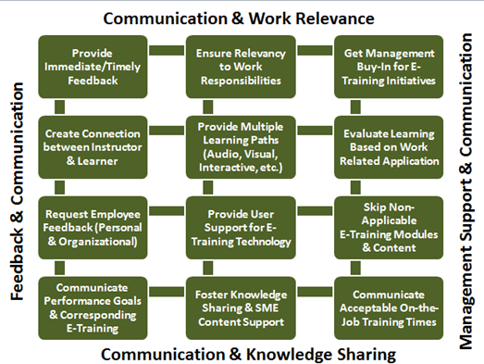
Figure 1. This diagram provides a more detailed look at the four best practices with an emphasis on communication. The various information blocks are interchangeable and may be used in any combination. Depending upon the type of training, the training audience, the training content, and the technology used to facilitate training, the emphasis may shift from block to block depending on where in the process an instructional team is and how important a particular area of focus is for the training to support learning and business goals. However, as a way to encourage a well-rounded approach to e-training, management support, knowledge sharing, feedback and user support, work relevance and communication should all be incorporated into any process that is used to enable successful e-training.

The glue that holds each of the best practices together is communication. Communication enables the four action points to work effectively and efficiently by creating a mutually cooperative relationship among all of the components of e-training best practices. This type of complementary process provides a foundation for larger areas of concern, such as employees, instructors, learning support and technology. In addition, it is possible to begin at any point in the process and still touch each planning area or to focus on one or two areas based on the needs of the e-training project.
Figure 2. A Model for E-Training Best Practices with Communication at its Center and Four Supports
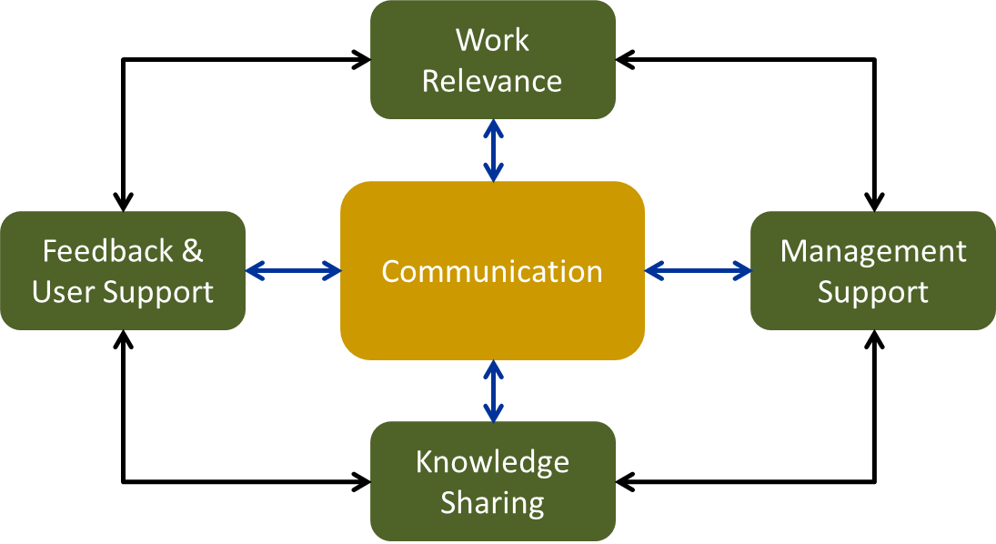
Figure 2. A model that represents best practices in e-training. Communication is the central point for e-training initiatives where feedback & support, work relevance, management support and knowledge sharing all work together to support e-training proposals and programs. There is not a beginning nor an end to the model. Instead communication is the focus with the understanding that successful e-training will include communication in general and communication that incorporates communication about work relevance, management support, knowledge sharing and feedback and user support.
Best practices provide a starting point for the process of creating interactive and engaging content, addressing audience needs, supporting business initiatives and using technology that facilitates learning. Instead of simply providing content using the same tools and in the same way no matter the audience or business objectives, best practices can provide their own type of motivation for the instructor and the organization. Irlbeck (2008), in an article that discusses the impact of employing best practices for an online university, explains that best practices can serve as a guide that motivates faculty to “strive to maintain the faculty–learner relationship, find ways to help the learning process be successful, assess the learning, and continue to build professional expertise for both the faculty and the learner” (p. 28). The goal of this paper is to create that guide that motivates workplace learning professionals to continually work to improve their processes and ultimately their e-training outcomes.
Describing the E-Training Best Practices Template
In order to apply the five best practices previously identified, it is important to visualize them as part of a larger framework that can be changed based on the needs of the project or initiative. With the introduction of agile methods of development in the software arena, departments outside of Information Technology (IT) are beginning to incorporate the same ideas into project management and instructional design. Consequently, structures that support e-training are being redefined to emphasize the importance of iteration and to focus on the needs of the project instead of the need to continue to do business as usual. When discussing various models that can be used in conjunction with the best practices, the focus will be more on iteration within those models.
If we look at the proposed e-training best practices as the depiction of a process method with interchangeability, it should be evident that different areas can be emphasized as each project dictates. To that end, there are four figures presented to show an emphasis on different best practices. The foundation of the figures remains the same because communication remains the key support for the structure. The e-training outcome remains the end result of the process. In figure one, e-training best practices are portrayed as a house where communication is the footing for the eventual e-training outcome in addition to the internal e-training action areas. The figure remains the same for three subsequent views, but in each there is a different emphasis which serves as a reminder that the area of focus can change based on the desired e-training outcome. Notice that none of the internal areas of action are removed. One or more are simply highlighted and the area given prominence will depend upon e-training content, anticipated audience, desired interaction and the business goals and objectives for each project. The following table provides additional information for each figure.

Table 3
Description of Process Models with Visual Emphasis Based on Different E-Training Scenarios
Figure | Emphasis | Examples of Use in E-Training Scenarios
Figure 3 | None | Figure 1 has the potential to support any e-training project and can provide a starting point. As additional information comes in and as business goals and objectives are clarified, one or more areas may be identified for emphasis later in a project or initiative. Figure 1, therefore, suggests a place to begin identifying the necessary building blocks for a project or initiative.
Figure 4 | Knowledge Sharing | When the emphasis is knowledge sharing, the project could be new training that is being tested in one department to determine feasibility. It could also be any project that provides the opportunity for a super user or train-the-trainer experience where it is expected that the first wave of students will later teach others who in turn may also teach others. Knowledge sharing opens the door to any project that encourages information sharing. Tests may be involved, but knowing the answers to those tests do not pose any concerns that one group will pass on the information to another group. Thus compliance training would not normally fall under knowledge sharing unless the training did not require a specific passing metric.
Figure 5 | Feedback & User Support  Work Relevance | Feedback & user support along with work relevance could be emphasized in those projects where specific and tangibles end goals are expected. It is not enough to provide training on a topic or information about a new process or way of doing business. When feedback & user support are combined with work relevance, the expectation is that the e-training is expected to result in concrete evidence of understanding of the material presented. The confirmation that this has occurred would be hands-on demonstrations within a person’s job responsibilities. Thus, e-training about changing a process would result in the training audience returning to work and engaging in the new process. There may be a transition period, but the end goal would be to enact change in how something is done.
Figure 6 | Management Support  Communication | Although communication is an important function within each of the best practices, it also stands on its own. When management support is tied to communication, it can be presumed that management classifies the training as relevant and important. Based on this emphasis, the training could be compliance training. However, unlike just an emphasis on management support which would also fit compliance training; management support and communication convey a higher level of importance where compliance training may be mandatory due to prior violations that could have resulted in production being put on hold or marketing being prohibited until the organization can show completion of the mandatory training.

Figure 3. E-Training Best Practices without Emphasis
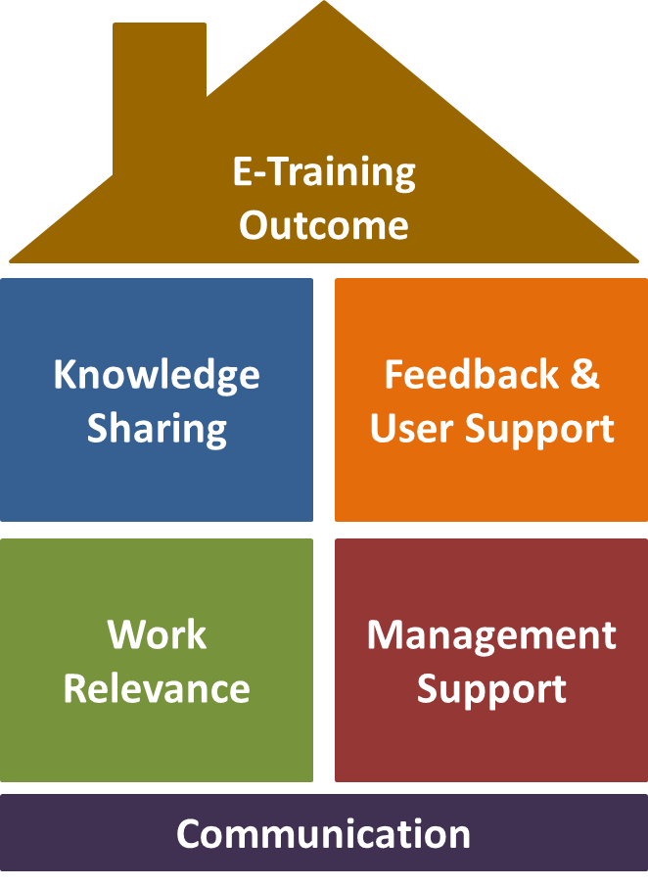
Figure 3. Visual depiction of the proposed e-training best practices without emphasis on any particular area. Communication provides the foundation with the e-training outcome identified as the end result. Knowledge sharing, feedback & user support, work relevance and management support are the e-training best practices that function as interchangeable blocks that can be removed or emphasized as needed for each e-training project or initiative.

Figure 4. E-Training Best Practices with Emphasis on Knowledge Sharing
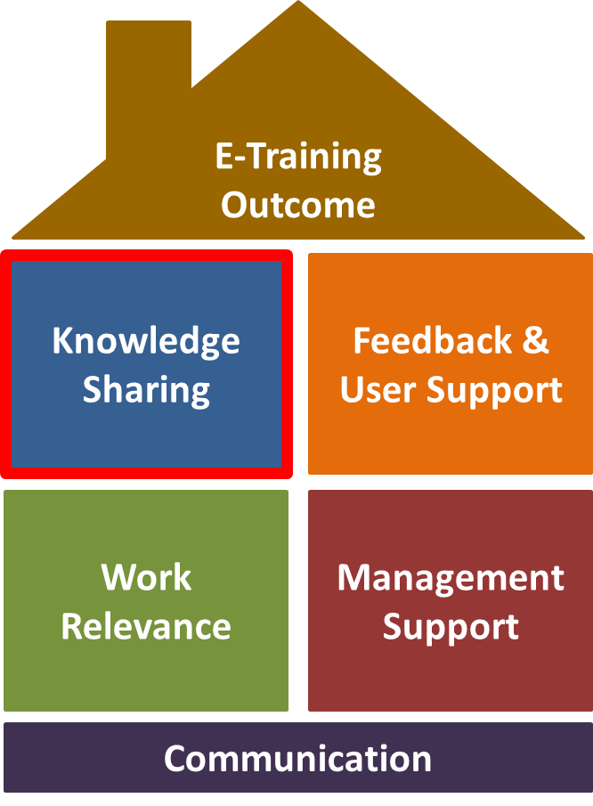
Figure 4. Visual depiction of the proposed e-training best practices with emphasis on knowledge sharing. Each section of the best practices visual remains a part of the image, but the focus on knowledge sharing represents a response to a need to address knowledge sharing in detail based on the e-training project requirements.

Figure 5. E-Training Best Practices with Emphasis on Work Relevance and Feedback & User Support
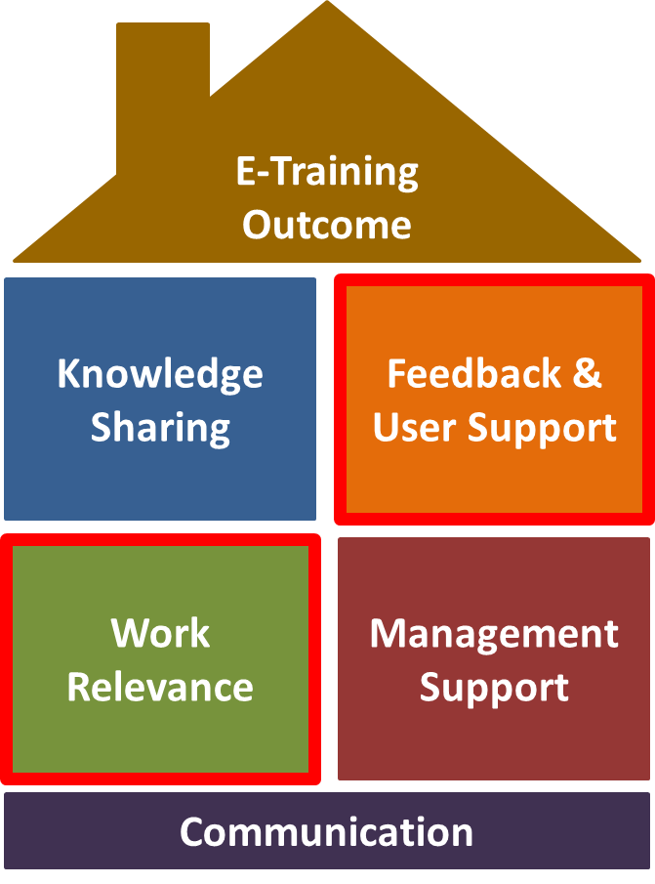
Figure 5. Visual depiction of the proposed e-training best practices with emphasis on work relevance and feedback & user support. Each section of the best practices visual remains a part of the image, but the focus on work relevance and feedback & user support represents a response to a need to address these two areas in detail based on the e-training project requirements.

Figure 6. E-Training Best Practices with Emphasis on Communication and Management Support.
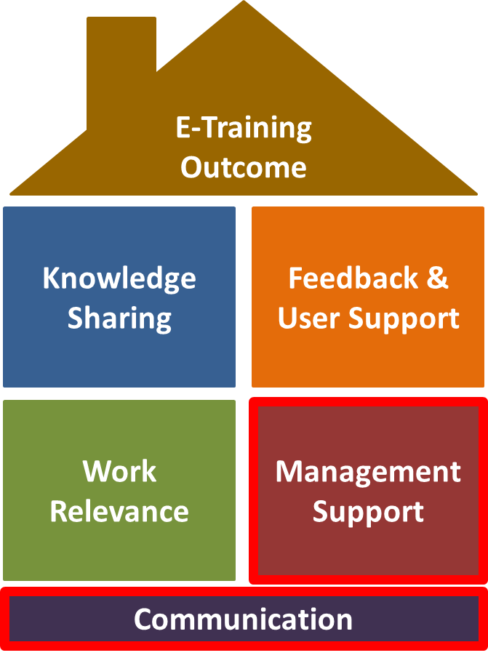
Figure 6. Visual depiction of the proposed e-training best practices with emphasis on knowledge sharing. Each section of the best practices visual remains a part of the image, but the focus on knowledge sharing represents a response to a need to address knowledge sharing in detail based on the e-training project requirements.

For each of the figures above, Table 3 provided examples of e-training projects that could correspond to the emphasis pinpointed in each figure. These examples serve as an illustration for application and are not exhaustive nor do they cover every e-training scenario.
Best practices are actionable items, but they are not a step-by-step process. Instead, best practices provide key action items that should be applied based on the needs of each individual project. As shown, one practice may be emphasized more or as needed based on the project or proposal at hand. Communication is key to any endeavor in business and is therefore, considered important no matter the project or the project’s deliverables. However, work relevance may be emphasized for customer service training or internal management training, but not as emphasized for mandatory compliance training although it would still be tied to compliance training. Management support could be far more important for new hire onboarding while knowledge sharing could be central to handling customer complaints in a consistent manner. While feedback might be emphasized for piloting e-training, user support could be emphasized more for e-training that is in place and important for a particular job type or certification path. Each area is important and should be considered for every e-training project, but which area is emphasized can and should depend upon the actual e-training project itself.
Understanding the importance of addressing each of the aforementioned best practices is the first step in applying this set of best practices, but in order for them to be successful, there are various models or processes that can be implemented to support them. Parrish (2013) quotes Scott Adams, the creator of Dilbert, a comic strip that pokes intelligent fun at the practices and actions in the workplace that actively harm instead of helping build teams and encourage teamwork, when he highlights the following:
[O]ne should have a system instead of a goal. The system-versus-goals model can be applied to most human endeavors. In the world of dieting, losing twenty pounds is a goal, but eating right is a system. In the exercise realm, running a marathon in under four hours is a goal, but exercising daily is a system. In business, making a million dollars is a goal, but being a serial entrepreneur is a system (p. 1).
For e-training best practices to be successful, systems that support e-training should be incorporated into e-training initiatives and implementations using best practices as the foundation and appropriate models as support. It is essential that e-training tie into business goals, but systems that can potentially support e-training projects, such as instructional design models, learning technology models, and evaluation models, are also important. This author proposes the use of ADDIE (Analysis, Design, Development, Implementation, Evaluation), TPACK (Technology, Pedagogy and Content Knowledge), Bates and Poole’s (2003) SECTIONS (Students, Ease of Use, Cost Structure, Teaching & Learning, Interactivity, Organization, Novelty and Speed), and Kirkpatrick’s Four Level Evaluation model. These are models that this author has successfully applied in the past and they serve only as a starting point. This list is not exhaustive and can be added to or subtracted from based on identifying which system or model has the potential to work best in a specific e-training endeavor.
Models should be chosen based on the e-training opportunity and just as e-training best practices can have more than one area of focus, this part of the process can also employ more than one model. At a high level, it is essential to understand the differences among the models. ADDIE, for example, is considered a project management model and SECTIONS is an instruction design model, but with an emphasis on selecting the right technology for the content, audience and organization. TPACK is also an instructional design model but with an emphasis on teachers and their familiarity or lack of familiarity with technology. Kirkpatrick’s Four Levels is an evaluation model and although it can be used to design training, it is best known for its use in determining the effectiveness of training events. Each model supports the goal of creating effective training and e-training opportunities, but each model may not need to be applied to every e-training project. The model that is selected for any e-training effort should depend upon the business goals and objectives, the content being presented, whether or not the training is required by a regulatory agency, the employee cohort identified as the audience, the technology available, the cost of the technology, the instructor and the instructor’s comfort level with technology. All of these can be used in conjunction with the e-training best practices presented earlier in this discussion. Before examining the application of e-training best practices and the models that can be used to support them, a definition of each of the models follows.
Models Defined
The following section describes each of the models and their features. This section will conclude with an example scenario and different ways that the various models can be applied while incorporating a focus on the best practices outlined in this paper. Both methods of tying a model to the e-training best practices are included in Appendices A and B for personal use.
ADDIE (Analysis, Design, Development, Implementation, Evaluation)
ADDIE functions as a project management model for instructional design, has been in use for decades, and focuses on managing the project from start to finish (Pearson & Myers, 2011). ADDIE has lately been challenged by SAM or the Successive Approximation Model proposed by Michael Allen (2012) and by Pearson & Myers (2011) in their article about a new approach to ADDIE because the model, if used exactly as it is defined, has the potential to be too limiting. However, Will Thalheimer, a workplace learning and performance researcher, disagrees when answering the question, “is the ADDIE model still relevant to instructional design” (Thalheimer, 2014). Thalheimer’s (2014) response is that
The ADDIE Model is a project-management model, it is NOT an
instructional design model. It says we ought to first do some sort of
analysis before we begin something. Then it says we ought to design
something, then develop it, then put the developed thing into practice by
implementing it in the targeted application situation. Then we should
evaluate the results and make improvements.
When describing effective design models in areas beyond education, for example, construction and product design; Pearson & Myers (2011) emphasize that the design processes that worked were “highly iterative and open-ended” (p.25). The important takeaway from this idea is that every model, every process, every set of best practices have the potential to be highly iterative and open-ended if that is the mindset that you adopt as you begin each new project. Thus, although SAM may be effective, ADDIE is still a relevant model and can be an effective model when used to manage the design process of a course from beginning to end. How ADDIE is applied and whether or not iteration is built in, remains within the purview of the project team, the instructional designer, the trainer, and anyone else involved in the process of addressing a business imperative, initiative or need with e-training. Even Allen, in a book review of Leaving ADDIE for SAM in Learning Solutions Magazine, agrees that “If the ADDIE model works for you, Allen argues, by all means use it!” (Sites, 2014).
TPACK (technology, pedagogy, and content knowledge).
TPACK is a system that focuses on technology integration with instruction (Koehler & Mishra, 2009). TPACK is a framework built upon Shulman’s 1986/1987 ideas about pedagogical content knowledge (PCK) and connects PCK with technologies for use by teachers for educational purposes (Koehler & Mishra, 2009). There are three parts of the framework, namely technological pedagogical knowledge (TPK), technological content knowledge (TCK) and pedagogical content knowledge (PCK). Each of these parts are overlapping and from the overlap come three additional sections, technological knowledge (TK), content knowledge (CK), and pedagogical knowledge (PK). Where all six converge is a middle point that leads to the name of the TPACK model or technological, pedagogical and content knowledge (see Figure 3.).
In order for a model to be effective, it helps to know how the model can be applied. The public schools of North Carolina have a wiki that explains how to operationalize the TPACK model (see http://ncltitpack.ncdpi.wikispaces.net/UnPACK+your+Discipline+TPACK). Their wiki provides a step-by-step guide that proposes the following path:
- “Choosing learning goals
- Making practical pedagogical decisions about the nature of the learning experience
- Selecting and sequencing appropriate activity types* to combine to form the learning experience
- Selecting formative and summative assessment strategies that will reveal what and how students are learning
- Selecting tools and resources that will best help students to benefit from the learning experience being planned” (UnPACK your Discipline TPACK, n.d.)
The idea behind this process is the hope that “by focusing first and primarily upon the content and nature of students’ curriculum-based learning activities and activity types, educators’ TPACK is developed authentically [emphasis in original], rather than technocentrically, as an integral aspect of instructional planning and implementation” (UnPACK your Discipline TPACK, n.d.). It is not uncommon for technology to take center stage and one of the reasons that the phrase “technology for the sake of technology” is so ubiquitous. TPACK accepts this reality and redirects the instructor to the content and the audience with the understanding that technology will be an important part of the process, but the process will not revolve around technology.

Figure 7. A Visual Definition of TPACK and its Interacting Elements
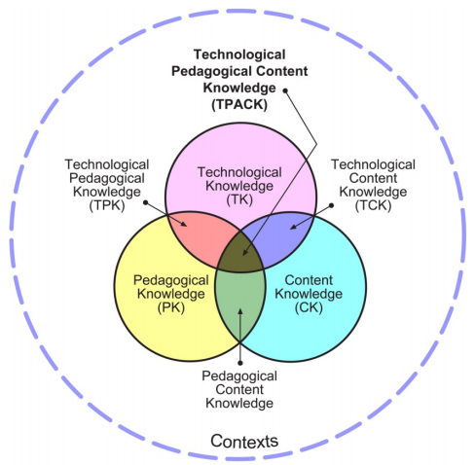
(Koehler & Mishra, 2009, p. 63)
Figure 7. This graphic illustrates the concepts and was designed by the creators of the current TPACK model that is built upon an earlier PCK model from Shulman (1987). This graphic details each area of the model, how those areas interact and the central coordinating idea that represents TPACK.
Where TPACK and the e-training best practices model converge are in the areas of feedback and user support and knowledge sharing. TPACK can certainly address work relevance and management support can be incorporated, but the focus remains on instructors and instructional design.

Kirkpatrick’s four level evaluation model.
Using Kirkpatrick’s Four Level Evaluation Model (referred to here as Kirkpatrick’s model) is another important model, because this is a system that emphasizes reaction, learning, behavior and results in addition to being business-focused (Kirkpatrick & Kirkpatrick, 2009). For example, it is not just about students’ learning, the model includes behavior and how or whether or not what has been learned is being applied on the job. Many articles refer to Kirkpatrick’s model based on the levels where reaction is level one and results are represented at level four. The following graphic illustrates each level.

Figure 8.
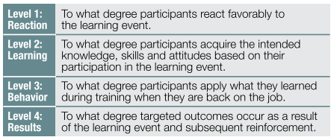
(Kirkpatrick & Kirkpatrick, 2009, p. 21)
Kirkpatrick’s model is focused on the evaluation of learning experiences. For any project that is management focused or any e-training initiative that is new and needs to be vetted, Kirkpatrick’s emphasize on results may be one of the more effective models to employ.

The SECTIONS Model (students, ease of use, cost structure, teaching & learning, interactivity, organization, novelty and speed).
The SECTIONS model, designed by Bates & Poole (2003), is a model for selecting the best technology for a particular training event. Each part of the SECTIONS model is explained in the table below.

Table 4
Description of Each Letter in the SECTIONS Model and the Area of Focus for that Letter
Letter and Area of Focus | Description
S – Students | “what is known about the students—or potential students—and the appropriateness of the technology for this particular group or range of students?”
E – Ease of Use and Reliability | “how easy is it for both teachers and students to use? How reliable and well tested is the technology?”
C – Costs | “what is the cost structure of each technology? What is the unit cost per learner?”
T –Teaching and Learning | “what kinds of learning are needed? What instructional approaches will best meet these needs? What are the best technologies for supporting this teaching and learning?”
I – Interactivity | “what kind of interaction does this technology enable?”
O – Organizational Issues | “what are the organizational requirements and the barriers to be removed before this technology can be used successfully? What changes in organization need to be made?”
N – Novelty | “how new is this technology?”
S – Speed | “how quickly can courses be mounted with this technology? How quickly can materials be change?”
(Bates & Poole, 2003, pp. 79 - 80).
This model is geared specifically toward the use of technology from an educational perspective. The idea is not to use technology because it is available nor because an organization has the money to spend, but to use technology in ways that supports learning and the transfer of content. For example, creating a game to teach customer service representatives how to respond to customers who are afraid of technology may be better served using scenario-based learning where they are given the opportunity to select different responses and to receive feedback on those responses. Memorizing how to respond in this example would not be as beneficial as understanding why one should respond in a particular way and why another response could be detrimental.
Each model is unique in how it can be applied, but they are also relatable and, in some cases, the various models share attributes to a degree. For example, both ADDIE and Kirkpatrick address evaluation. For the ADDIE model, it is one step in a five-step process while the Kirkpatrick model is focused on evaluation from steps one through four. The TPACK model and the SECTIONS model both emphasize selecting the correct technology within the context of identifying the audience and creating engaging pedagogically sound content. ADDIE and TPACK share similar process steps by beginning with an analysis and continuing through implementation to an evaluation. TPACK adds on the importance of selecting the correct tools and resources because one of the goals of TPACK is to address the challenges that impact instructors who integrate technology into their courses and who may not be comfortable with that technology (Koehler & Mishra, 2009, p. 61). Each model can be applied alone or in conjunction with other models depending on the needs of the project. Each model or models should also be applied within the framework of e-training best practices. An example of applying a model within the framework of e-training best practices is displayed in Table 3. Using the Kirkpatrick model as the primary model for an e-training project, the e-training best practices are outlined and the connection between the two explained. This table was created to assist in identifying where the Kirkpatrick model converges with e-training best practices and how the author sees the framework and Kirkpatrick’s model connecting. The mapping is mixed because some e-training best practices connect to more than one of the four levels in Kirkpatrick’s model and some of the levels in Kirkpatrick’s connect to multiple areas of the e-training best practices. Figure 9 visually depicts the connections between e-training best practices and the four Kirkpatrick levels and the table 5 provides a detailed description of why the various levels and best practices are paired in the third column. Both serve to identify an example of how the Kirkpatrick model is tied to e-training best practices. This method of connecting a model to e-training best practices is possible for each model described and any additional models that an instructional designer or course team may decide to use. The purpose of mapping is to identify, if the project is a new project, or to confirm, if the project is ongoing, that e-training best practices are being incorporated into each e-training project.

Figure 9. Kirkpatrick’s Four Levels of Evaluation Tied to Each E-Training Best Practice
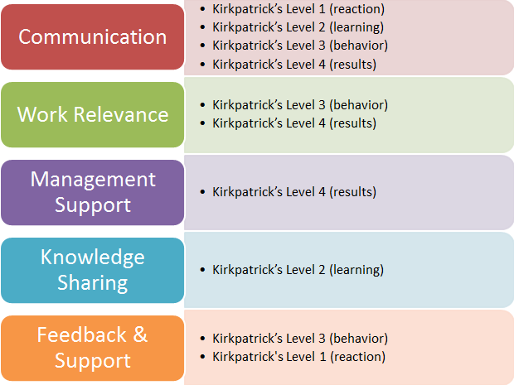
Figure 9. This graphic represents each element of the e-training best practices and the corresponding areas of Kirkpatrick’s Four Levels of Evaluation that are tied together based on their impact on e-training projects and initiatives. For example, knowledge sharing can be addressed using the questions and criteria presented in Kirkpatrick’s Level 2 because the focus is on learning and learning is a form of knowledge sharing. This layout provides an opportunity to confirm that the model selected supports e-training best practices.

Table 5
Detailed description of the Connection between E-Training Best Practices and each Level in the Kirkpatrick model
E-Training  Best Practices | Steps in the  Kirkpatrick Model | Connection between the Selected Model  and E-Training Best Practices
Communication | Level 1 (reaction)  Level 2 (learning)  Level 3 (behavior)  Level 4 (results) | Communication is a requirement for every level in Kirkpatrick’s model. Instructions will not be able to identify employee reactions without communication, learning does not occur without communication, behavior cannot be assessed without communicating what is seen and documented, and results also require communication in order to identify and communicate impact to business leaders.
Work Relevance | Level 3 (behavior)  Level 4 (results) | How learning is applied when the learner is back on the job contributes to the ideas behind work relevance. Connecting the learning to work is key when attempting to create learning that supports not only the learner, but the organization as well. This outcome can be assessed by both behavior changes and the results of the training.
Management Support | Level 4 (results) | In business, management is about results. Gathering, documenting and sharing results supports standard business ideology. In addition, level 4 is about targeted outcomes. Targeted outcomes are certainly helpful to instructional designers and course teams, but they should also be communicated to management as a way to show evidence of desired outcomes and possibly as a way to support future investment in e-training opportunities because a tangible benefit is being communicated to those who may have the ability to support or deny support for future e-training.
Knowledge Sharing | Level 2 (learning)  Level 3 (behavior) | Learning and behaviors are impacted by knowledge sharing, feedback and user support in that each process has the potential to encourage or discourage each best practice. Participation, for example, is a part of knowledge sharing and participation in learning events provides learners with the opportunity to share their understanding of topics and their lack of understanding as well. Participation also opens the door to alert an instructor that a student is struggling or needs help. Participation also provides opportunities for user support by showing the instructor how students are interacting with content and activities.
Feedback & User Support | Level 1 (reaction) | Feedback opens the door to user support and user support in turn has the potential to improve feedback. A favorable reaction is a nice to have, but paying attention to all reactions is important as well.

The Kirkpatrick model supports the business while at the same time focusing on the learner. However, this model was created for the workforce so the emphasis is not so much on the learner as on the skills and knowledge acquired and the impact that the learning has on the learner, the workplace and the goals of the business. The process of identifying how each model connects to e-training best practices can be done for each model. This is just one example of the connections between a model and e-training best practices. Each model should speak to each of the e-training best practices for a successful e-training experience. If a model does not address each of the best practices, that model can be supported by incorporating other models or by addressing the area not covered as an individual action. Emphasis was placed on Kirkpatrick’s Four Levels of Evaluation because this model emphasizes the business focus of e-training with the connection to work relevance and the business bottom line.
Model Application
As previously discussed, e-training best practices are the foundation for e-training projects, and these initiatives also need project, design, and evaluation models to assist in developing and re-designing e-training courses and programs. E-training has the potential to support business objectives and, as evidenced by the investment in online learning and employee development, businesses want these projects to succeed. The challenge is that projects are not closed systems with a beginning and a desired end. E-training projects are made up of course materials, individual modules, audio and video training files, full courses, certification programs, job aids, knowledge bases, simulations, job and industry information and various other resources for content. E-training best practices provide the foundation and ADDIE, TPACK, SECTIONS and Kirkpatrick’s Four Levels of Evaluation provide the actions. Thus, e-training best practices go hand-in-hand with models for project management, course design, technology selection and course or program evaluation.
Setting the Stage for Success
If best practices serve as a framework, models are the tools that support building with that framework. Best practices combined with supporting models are similar to having a map with the option to get to the same destination using multiple paths. This is a key feature of the recommended e-training best practices because it is important that e-training instructional designers and teams are flexible as there is no one right way to accomplish a training goal. In order to apply the ideas presented in this paper, it is important to ask questions. Who is the e-training for? What is the e-training supposed to accomplish? What business objectives are driving this e-training project? Why is this e-training important to the audience that it is directed toward? Where is the best place for the e-training to live? All of these questions and more can cause concern for e-training projects and e-training teams, but it is questions and not assumptions that provide a positive impact for projects. For example, assuming that improving a f2f course means moving it to an online format does not take into account the audience that the course is targeting nor the information being presented. Parts of the course may work well in an online format, but the rest of the course may still need to be f2f. If that is the case, a blended learning strategy becomes more appealing. Another example is a course that is already online, but the information is out of date. This course may be fine remaining online, but the interaction may need to be improved in order to support retention. If the course was previously documented as having had students start and then stop without completing, tying the course to business goals and emphasizing relevance to work for the employee audience might also be important factors to consider.
What can be done to create e-training that supports learning and the application of that learning? Begin with the important and high level concerns that will need to be addressed, determine the best tools to use to accomplish the project’s unique and specific goals, and be willing to iterate and focus on careful evaluation of all steps in the process. ADDIE is a step-by-step process, but the design and development steps are excellent areas to repeatedly test on multiple audiences as projects progress. The same can be said for the SECTIONS model or the TPACK model. For example, with SECTIONS, teaching and learning, interactivity and novelty can be revisited as a project develops to ensure that the material being presented solicits the response instructors are aiming for and includes the amount of interactivity needed to convey ideas and confirm understanding. Effectiveness can also be tested on different audiences for feedback and various opinions can be solicited to determine whether or not the novelty of an activity, material or teaching approach is truly novel by others’ definitions.
Using earlier figures as a guide, a visual representation of the relationship between e-training best practices and e-training models are shown below. Each block or model is interchangeable and can be utilized in its entirety or pieces of a model can be identified to work with other models. As an example, ADDIE has been used individually, but ADDIE does not have a focus on novelty or ease of use which are both central to the SECTIONS model. Therefore, depending on the project, both models could be used to cover all areas of concern. Instructional design teams can and should pull together those pieces of each model that support their initiative so this may mean using multiple models for one project. In addition, if an e-training initiative is motivated by the need for a specific business outcome, ADDIE can still be used for process, but Kirkpatrick’s Four Levels would also provide supporting evidence for the e-training outcome, learner responsiveness and the overall effectiveness of the e-training. As previously mentioned, the models described in this paper are not exhaustive. Other models do exist and should also be evaluated based on the needs of the initiative.

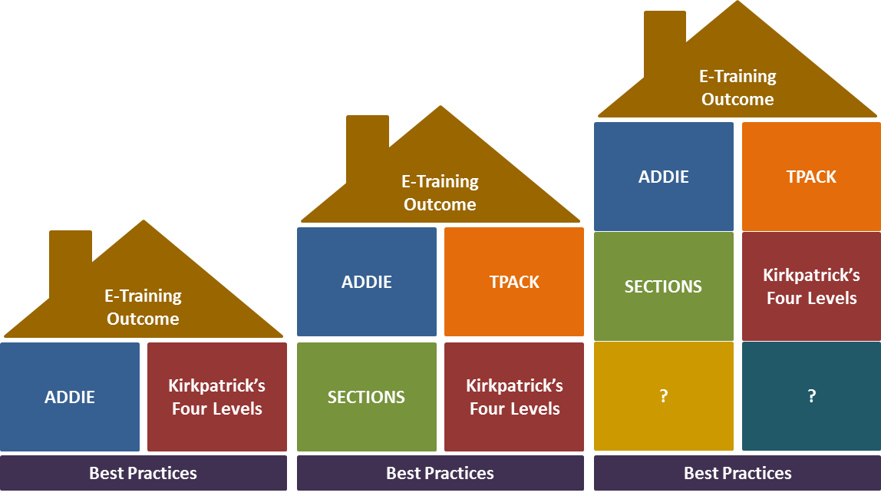
Figure 10

Figure 10. Illustration of e-training best practices combined with the aforementioned instructional designed models (ADDIE, TPACK, SECTIONS and Kirkpatrick’s Four Levels of Evaluation). The images display various combinations of instructional design models where best practices remain the foundation and e-training outcomes remain the end goal. The illustration also provides additional space for instructional design models not mentioned here that can and should come from the course design teams based on their e-training project needs where and when other models become more relevant for their design strategy.

Applying Best Practices
At this time, e-training best practices have been defined, various models for use with those best practices have been identified and discussion around how the two may interact has been established. What has not been discussed is how to approach using the best practices and models in a project. The following lists the phases, steps and questions that can assist in the application of e-training best practices and e-training models.
Begin the process by (1) determining the end goal for the project, (2) identifying the audience for the project and why the e-training is important to that audience, (3) ensuring that the business needs that the project will address are clear, (4) beginning to think about the available technology that can be used for the e-training and (5) confirming stakeholder agreement. Once these five areas have been discussed and evaluated, the next step is to validate the needs and the wants for the project. For example, the business may need an online course that addresses customer service issues. While the course design team may want to implement the project that typically would have been done in MS PowerPoint in Articulate Storyline instead because PowerPoint has limited availability for hands-on interactivity while Articulate Storyline offers course designers the opportunity to create interactions where learners must react to the information on each slide. Understanding both wants and needs is critical to understanding what drives each project and can help to mitigate challenges that previously would have been unforeseen. For example, what the e-training project lead wants may not conform to what the business needs are and both need to be in synch if the project is to be successful. Being aware of those wants and needs is a first step to addressing them. The following questions are relevant to the matter of the project’s needs and wants:
- I (the e-training project lead) want/need ?
- The business wants/needs ?
- The instructional design team wants/needs ?
- The adult learner wants/needs ?
- The department wants/needs ?
Two additional questions are for those e-training projects where the stakeholders are the human resources, compliance and/or legal departments:
- The Human Resource department wants/ needs (optional) ?
- The Compliance/Legal department wants/needs (optional) ?
The next step in the process is to take a deeper look into the content and the information that needs to be communicated to the learners. In this part of the process, it is also important to begin looking at how technology can be used to present training and to consider how the material can be interactively presented. A fully online course may be a part of the solution, but not the entire solution. It may also be determined that electronically accessible job aids would facilitate the use of the newly learned information and content when the employee returns to work. The questions that need to be asked for this step in the process are:
- Content can be effectively communicated by __________.
- The learning activities that can support the content are __________.
- The technology (ies) that can support the content and learning activities is/are __________.
- The learning intervention (one course, multiple courses, job aids, and any other e-training method that enables learning) that can support the content, learning activities and technology used is/are __________.
Once the first three steps have been completed, the process moves on to the second phase of the process. In this stage, it is important to identify the critical needs for the project and to tie those needs to an applicable model or models. The following set of questions addresses this step by answering the question, “What are the critical needs for the project?” A few examples are listed below with a suggested model:
- If a business initiative is a critical need, try Kirpatrick’s Four Levels of Evaluation.
- If access to technology for learners in remote locations is a critical need, try the SECTIONS model.
- If mandatory compliance training is a critical need, try the ADDIE model along with the Kirkpatrick model.
- If e-training costs are a concern, try the Kirkpatrick model.
- If redesigning a (previously successful) course is a critical need, try SECTIONS.
- If redesigning a (previously unsuccessful) course is a critical need, try the ADDIE model in conjunction with the SECTIONS model.
- If updating a face-to-face course to e-training is a critical need, try TPACK.
Another part of the second phase is to create a test case for the e-training and to present that test case to a pilot group. After the pilot group has interacted with the e-training, the following questions should be asked and answered:
- How did students react to the training
- What stood out for a majority of the respondents
- What stood out most for the employee audience
- Is the technology used helping or hurting the transfer of knowledge
- Based on the response from the pilot group, is it better to provide one course, multiple courses, job aids, or other e-training interventions
This part of the process may require and benefit from multiple iterations if time permits. Additionally, an organization can have several pilot groups to gain a wider perspective on the response to the e-training either participating at the same time or participating for different iterations of the project. After iteration has been completed, the questions to ask should address audience response and provide takeaways or next steps. A short list of questions follows:
- What worked?
- What didn’t work?
- Why did x work/not work?
- Are there any changes that need to be made based on audience response?
- If yes, identify changes and how they can address the areas of concern.
The final phase of the process is to (1) create the e-training and publish to the employee audience that it was created for, (2) monitor progress as employees work through the course material, and (3) evaluate and document employee response to the e-training for future use. For each stage of the application of e-training best practices, see Appendix C where the phase, steps and questions and placed in a format that can be used as a checklist.

Conclusion
Interestingly, little discussion is offered on the reasons that businesses select e-training and what corporations think e-training can help them accomplish other than to reiterate the belief that e-training will provide (1) cost savings, (2) flexibility, (3) easier distribution to employees, (4) consistency across business units, (5) no need to travel for training, (6) just-in-time content delivery, and (7) the opportunity to train and re-train (Paulsen, 2009; Jia, Wang, Ran, Yang, et. al., 2011; Harun, 2002; Stewart & Waight, 2008; Newton & Doonga, 2007; and Seraphim, 2010). Stewart & Waight (2008) sum up the reality nicely, “though e-learning investments have not achieved the expectations posited by Wall Street over the last nine years, the benefits of e-learning have kept companies interested in including e-learning as a component of their learning strategy (p. 294).
In an effort to address the need for e-training that is effective, a framework that incorporates best practices, relevant models and a potential implementation process have been proposed by this author. The emphasis for the recommendations are that both best practices and the relevant models should be employed based on the actual e-training project itself. There is no one-size-fits-all for e-training projects because industries are different, businesses have different goals, the employee audience could be culturally, geographically and generationally diverse and one size technology does not fit all. Therefore, identifying those components that make each e-training project unique and using those elements to determine the most effective e-training best practices and the most relevant e-training models is the goal of this author.
References
AMSN Debuts on Healthstream. (2013). Academy of Medical-Surgical Nurses. Retrieved from
http://www.amsn.org/debuts-healthstream
Al-Abri, R., & Al-Hashmi, I. (2007). The learning organisation and health care education. Sultan
Qaboos University Medical Journal, 7(3), 207-214.
Alliger, G. M., & Janak, E. A. (1989). Kirkpatrick’s levels of training criteria: Thirty years
later. Personnel Psychology, 42(2), 331-342.
Baghdadi, Z. D. (2011). Best Practices in Online Education: Online Instructors, Courses, and
Administrators. Turkish Online Journal Of Distance Education,12(3), 109-117.
Baghdadi, Z. D. (2011). Best Practices in Online Education: Online Instructors, Courses, and
Administrators. Turkish Online Journal Of Distance Education, 12(3), 109-117.
Barnes, A. (2013). Breaking through generational stereotypes. T+D, 67(6), 30.
Bates, A.W., & Poole, G. (2003). Effective teaching with technology in higher education:
Foundations for success. San Francisco, CA: Jossey-Bass.
Biech, E. (2008). The learning organization today: An interview with Peter Senge. In Biech, E.
(Ed.), ASTD handbook for workplace learning professionals (pp. 649 – 656). Virginia: ASTD Press.
Berge, Z. L. & Kendrick A. A.(2005). Can interest in distance training be sustained in corporate
organizations? International Journal of Instructional Technology & Distance Learning,
2(2). Retrieved from http://itdl.org/Journal/Feb_05/Feb_05.pdf
Berge, Z. (1998). Conceptual Frameworks in Distance Training and Education. In D. A. Schreiber
& Z. L. Berge (Eds.), Distance training: How innovative organizations are using
technology to maximize learning and meet business objectives (pp. 19 – 36). San
Francisco: Jossey-Bass.

Berge, Z. L. (2001). Linking the organizational perspective with distance training and education
programs. In Z. L. Berge (Ed.), Sustaining distance training: Integrating learning
technologies into the fabric of the enterprise (pp. 124 – 143). San Francisco, California:
Jossey-Bass.
Best Awards. (2013). ASTD best awards 2013. Retrieved from http://www.astd.org/About/ASTD-
Awards/Best-Awards
Bozarth, J. (2011, December). Nuts and bolts: Inviting interaction. Learning Solutions Magazine.
Retrieved from http://www.learningsolutionsmag.com/articles/805/nuts-and-bolts-inviting- interaction
Brown, K., & Charlier, S. (2013). An integrative model of e-learning use: Leveraging theory to
understand and increase usage. Human Resource Management Review, 23(1), 37-49.
Bullen, M. & Janes, D. P. (2007). Making the transition to e-learning: Strategies and issues.
Hershey, PA: Information Science Publishing
Business Dictionary. n.d. Define best practice. Retrieved from
http://www.businessdictionary.com/definition/best-practice.html.
Customer Stories. (2007). Healthstream. Retrieved from http://www.healthstream.com/stories.aspx
Czeropski, S. (2012). Use of asynchronous discussions for corporate training: A case study.
Performance Improvement, 51(9), 14-21.
Define Best Practices. (2014). Retrieved from

www.businessdictionary.com/definition/best-
practice.html
Define Best Practices. n.d. Retrieved from
https://www.google.com/search?q=define+best+practices&rlz=1C1CHFX_enUS518US518&oq=define+best+practices&aqs=chrome..69i57j0l5.5195j0j9&sourceid=chrome&espv=210&es_sm=122&ie=UTF-8

Define Education. n.d. Retrieved from
https://www.google.com/search?q=define+education&oq=define+education&aqs=chrome..69i57.2688822j0j7&sourceid=chrome&es_sm=122&ie=UTF-8#q=define+education
Define Instruction. n.d. Retrieved from
https://www.google.com/search?q=define+instruction&oq=define+instruction&aqs=chrome..69i57j0l5.2194j0j9&sourceid=chrome&es_sm=122&ie=UTF-8
Define Learning. n.d. Retrieved from
https://www.google.com/search?q=define+learning&oq=define+learning&aqs=chrome..69i57j0j69i65j0l3.1630j0j9&sourceid=chrome&es_sm=122&ie=UTF-8
Define Training. n.d. Retrieved from
https://www.google.com/search?q=define+training&oq=define+training&aqs=chrome..69i57j0l5.1679j0j9&sourceid=chrome&es_sm=122&ie=UTF-8
Define Intervene. 2014. Retrieved from http://www.merriam-webster.com/dictionary/intervene
DiLello, A. & Vaast, K. (2003, May 1). Using adult learning theory. Chief Learning Officer:
Solutions for Enterprise Productivity. Retrieved from http://clomedia.com/articles/view/using_adult_learning_theory/1
Dobrin, C. (2012, March 9). Infographic: How to train your employees to handle your social
media [Web log post]. Retrieved from
http://www.mindflash.com/blog/2012/03/infographic-how-to-train-your-employees-to-handle-your-social-media/
Eyre, E. (2011). L&D undergoing a renaissance during interesting times. Training Journal, 8-10.
Gonnering, R. S. (2011). The seductive allure of "Best Practices": Improved outcome is a
delicate dance between structure and Process. Emergence: Complexity & Organization,
13(4), 94-101.

Google. n.d. Define best practice. Retrieved from
https://www.google.com/search?q=define+best+practice&oq=define+best+practice&aqs=chrome..69i57j0l5.2585j0j9&sourceid=chrome&es_sm=122&ie=UTF-8
Goule, E., & Stamatiadis, F. (2012). How Can Socratian Methods Facilitate E-Learning in the
Business Environment?. International Journal Of Advanced Corporate Learning, 5(1), 21-
25.
Gravett, L., & Throckmorton, R. (2011). Bridging the Generation Gap. Bridging The Generation
Gap. Pompton Plains, New Jersey: The Career Press, Inc.
Green, M. (2011). 2011 ASTD State of the Industry Report. T+D, 65(11), 44. Retrieved from http://www.astd.org/Publications/Research-Reports/2011/2011-State-of-the-Industry-
Report
Haneberg, L. (2008). Organizational culture. In Biech, E. (Ed.), ASTD handbook for workplace
learning professionals (pp. 625 – 632). Virginia: ASTD Press.
Harun, M. (2001). Integrating E-Learning into the Workplace. Internet And Higher Education,
4(3-4), 301-10.
Holmberg, B. (2005). The evolution, principles and practices of distance education.
Oldenburg, Germany: Carl von Ossietzky Universitaet Oldenburg.
Hyland, L. (2010). Designing e-learning for business impact. Training Journal, 54-57.
Irlbeck, S. A. (2008). Implementation of best practices for online teaching and learning in an
online institution. Performance Improvement, 47(10), 25-29.
Jia, H., Wang, M., Ran, W., Yang, S., Liao, J., & Chiu, D. (2001). Design of a performance-oriented
workplace e-learning system using ontology. Expert Systems with Applications, 38(4),
3372-3382.
Ketter, P. (2009, October). Committed to excellence. T+D. Retrieved from
http://www.astd.org/Publications/Magazines/TD/TD-Archive/2009/10/Committed-to-Excellence

Kineo Insight. n.d. Rapid guide: Rapid e-learning for product knowledge. Retrieved from
http://www.kineo.com/m/0/kineo-product-knowledge.pdf
Kirkman, G., & Shaw, E. L. (1997). Effects of an oral advance organizer on immediate and
delayed retention (Report No. TM027960). Washington, DC: Office of Educational
Research and Improvement.
Knowles, M. S. “Adult Learning.” ASTD Training & Development Handbook: A Guide to Human
Resource Development. R. L. Craig (ed.). Fourth Edition. New York: McGraw-Hill, 1996.
Koehler, M. J., & Mishra, P. (2009). What is technological pedagogical content knowledge?
Contemporary Issues in Technology and Teacher Education, 9(1), 60-70.
Kok, A. (2013). How to manage the inclusion of e-learning in learning strategy. International
Journal of Advanced Corporate Learning, 6(1), 20-27. doi:10.3991/ijac.v6i1.2341
Instructional Scaffolding. (2014). InformEd. Retrieved from
http://www.opencolleges.edu.au/informed/teacher-resources/scaffolding-in-education-a-definitive-guide/#ixzz2opvczkeI
jllorens. (2011, April 19). Resetting your “always start with level 1” default [Web log post].
Retrieved from http://www1.astd.org/Blog/post/Resetting-Your-e2809cAlways-Start-with-Level-1e2809d-Default.aspx
Kirkpatrick, J. (2007). The hidden power of Kirkpatrick’s four levels. T+D, 61(8), 34.
Kirkpatrick, J., & Kirkpatrick, W. (2009). The Kirkpatrick model: Past, present and future. Chief
Learning Officer, 8(11), 20-55.
Kuhlmann, T. (2012). A closer look at e-learning: Expert advice on why technology-based training
works. Industrial Safety & Hygiene News, 46(1), 56.
McLagan, P. A. (2008). Competencies and the changing world of work. In Biech, E. (Ed.), ASTD
handbook for workplace learning professionals (pp. 127 – 146). Virginia: ASTD Press.

Stolovitch, H. D. & Keeps, E. J. (2008). Selecting solutions to improve workplace performance. In
Biech, E. (Ed.), ASTD handbook for workplace learning professionals (pp. 147 – 177). Virginia: ASTD Press.
Sink, D. L. (2008). Instructional design models and learning theories. In Biech, E. (Ed.), ASTD handbook
for workplace learning professionals (pp. 195 – 212). Virginia: ASTD Press.
Herrmann-Nehdi, A. (2008). The learner: What we need to know. In Biech, E. (Ed.), ASTD handbook for
workplace learning professionals (pp. 213 – 231). Virginia: ASTD Press.
Miller, L. (2012). 2012 ASTD State of the Industry Report: Organizations Continue to Invest in
Workplace Learning. T+D, 66(11), 42. Retrieved from http://www.astd.org/Professional-Resources/State-of-the-Industry-Report
Mimicopoulos, M. G. n.d. The global political economy in the knowledge age. Retrieved from
http://unpan1.un.org/intradoc/groups/public/documents/un/unpan024391.pdf
Moore, M. G. & Kearsley, G. (2012). Distance education: A systems view of online learning (3rd
ed.). Belmont, CA: Wadsworth, Cengage Learning.
Mosher, B. (2013). Speak the Language of Business. Chief Learning Officer, 12(9), 12.
Netteland, G. (2009). Implementation of e-learning in a large organization: The critical role of
relevance to work. International Journal of Advanced Corporate Learning, 2(3), 58 - 65.
Newton, R., & Doonga, N. (2007). Corporate e-learning: Justification for implementation and
evaluation of benefits. A study examining the views of training managers and training
providers. Education For Information, 25(2), 111-130.
Fred Nickols. (2011, April, 21). Leveraging the Kirkpatrick model [Web log post]. Retrieved from
http://www.trainingjournal.com/blog/articles-blogs-leveraging-the-kirkpatrick-model/
Olafsen, R. N. & Cetindamar, D. (2005). E-learning in a competitive firm setting. Innovations in
Education and Teaching International, 42(4), 325 – 335.
Parrish, S. (2013, December 19). How to Fail at Almost Everything and Still Win Big [Web log
post]. Retrieved from http://www.farnamstreetblog.com/2013/12/scott-adams-fail-at-everything/
Paulsen, M. (2009). Successful E-Learning in Small and Medium-Sized Enterprises. European
Journal Of Open, Distance And E-Learning, (1),
Peters, O., Holmberg, B., & Moore, M. G. (2008). A personal configuration, Distances et
saviors, 3(6), 455-470. Retrieved from http://www.cairn.info/revue-distances-et-savoirs-2008-3-page-455.htm
Phillips, P. W. B. (2007). Governing transformative technological innovation [Elgar Online
version]. Retrieved from http://www.e-elgar.co.uk/g_emag.lasso?ebook13isbn=9781781951002&title=Governing%20Transformative%20Technological%20Innovation
Precyse Solutions, LLC. (2011). Precyse and Healthstream partner to deliver robust ICD-10 education
program [Press release]. Retrieved from
http://www.precyse.com/resources/Precyse%20and%20HealthStream%20Partner%20to%20Deliver%20Robust%20ICD-10%20Education%20Program%20061511%20(3).pdf
Prokopeak, M. (2011, October 26). Why best practices are bad for business. Chief Learning Office:
Solutions for Enterprise Productivity. Retrieved from http://clomedia.com/articles/view/why-best-practices-are-bad-for-business
Rabak, L. & Cleveland-Innes, M. (2006). Acceptance and resistance to corporate e-learning: A
case from the retail sector. Journal of Distance Education, 21(2), 115 – 134.
Rosenberg, M. J. (2001). E-learning: Building successful online learning in your organization. New York,
New York: McGraw-Hill.
Rosenberg, M. J. (2006). Beyond e-learning: Approaches and technologies to enhance
organizational knowledge, learning, and performance. San Francisco, CA: John Wiley
and Sons, Inc.
Sanford, C. (2012, February 16). The limits of best practices. Chief Learning Office: Solutions for
Enterprise Productivity. Retrieved from http://clomedia.com/articles/view/the-limits-of-best-practices
Seraphim, K. (2010). Enticers and barriers to e-learning based distance corporate training: The
case of a Greek bank. Turkish Online Journal of Distance Education – TOJDE, 11(4), 109 –
120.
Schomberg, W. & Milliken, D. (2013, October 25). UK economy accelerates to fastest growth
since 2010. Reuters Edition US. Retrieved from
http://www.reuters.com/article/2013/10/25/us-britain-economy-idUSBRE99O09H20131025
Schreiber, D. A. & Berge, Z. L. (Eds.). (1998). Distance training: How innovative
organizations are using technology to maximize learning and meet business objectives. San Francisco, California: Jossey-Bass.
Shulman, L. (1987). Knowledge and teaching: Foundations of the new reform. Harvard
Educational Review, 57(1), 1-22.
Stolovitch, H. D. & Keeps, E. J. (2002). Telling ain’t training. Alexandria, VA: American Society for
Training & Development.
Tsai, S. & Machado, P. (2002). E-learning basics: Essay, e-learning, online learning, web-based
learning, or distance learning: Unveiling the ambiguity in current terminology. Retrieved
from http://elearnmag.acm.org/archive.cfm?aid=568597
UnPACK your Discipline TPACK. (n.d.). North Carolina Learning Technology Initiative. Retrieved
from http://ncltitpack.ncdpi.wikispaces.net/UnPACK+your+Discipline+TPACK
Waight, C. L., & Stewart, B. (2005). Valuing the Adult Learner in E-Learning: A Conceptual Model
for Corporate Settings. Online Submission.
What is TPACK? (2014). The EDT 514 TPACK Wiki. Retrieved from
http://edt514tpack.wikispaces.com/What+is+TPACK
Who Can Use the TPACK model. (2014). The EDT 514 TPACK Wiki. Retrieved from
http://edt514tpack.wikispaces.com/Who+Can+Use+the+TPACK+model
Zaporzan, D. (2010). Four generations, one workplace: Watch us work. CMA Management,
84(6), 12-13.
Appendix A
Identifying the steps in one or more instructional design models that support
each of the e-training best practices
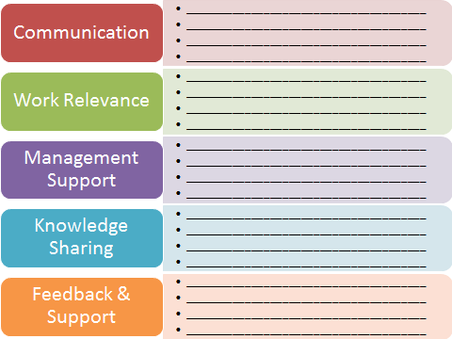

Appendix B
Connecting e-training best practices and instructional design models
E-Training Best Practices | Steps in the ________________________ Model | Connection between the _________________________ Model and E-Training Best Practices
Example: E-Training Project Emphasis on Work Relevance  In this example, work relevance is the focus and the selected model is the ADDIE model. All of the steps in the mode, except implementation, touch upon work relevance. This is a helpful distinguishing factor when ensuring that best practices are incorporated into course design. | *Analyze  *Design  *Develop  Implement  *Evaluate  *Used to identify the steps in the model that are connected to a specific best practice or practices. | Analyze the e-training project in terms of how the content and audience needs can be tied to work relevance.  Design the e-training with work relevance as a key factor in communicating how the training supports the employee.  Develop e-training that provides the necessary content with reminders and learning activities that reinforce the connection to work relevance.  Evaluate the training in reference to whether or not employees were able to apply what they learned and can show relevance to their jobs, tasks and duties.
Appendix C
E-Training best practices workflow process
☐Phase One
☐ Step One
- ☐Determine the end goal for the project.
- ☐Identify the audience for the project.
  - ☐Why is e-training important for this specific audience?
  - ☐How can e-training support this audience?
- ☐Ensure that the business needs that the project will address are clear.
  - ☐Ask questions to confirm business needs with the appropriate workplace stakeholders.
  - ☐Review understanding of business needs with stakeholders.
- ☐Begin brainstorming and/or testing the available technology that can be used for the e-training initiative.
  - ☐Determine if current technology will meet the needs of the project. Although this is an initial assessment, support the selection of technology using an instructional design model.
  - ☐If current technology does not meet project needs, research and support a request for other or additional technology.
  - ☐ If funding is available for the technology, ensure that the technology, training in the use of the technology and time to both learn the technology and produce e-training are accounted for in the project plan.
- ☐ Confirm stakeholder agreement with for the following:
  - ☐ Project goal,
  - ☐ Business needs,
  - ☐ Audience, and
  - ☐ Technology selection.
☐ Step Two
- ☐ Identify project needs/wants by answering the following questions (these questions are also designed to determine personal and team bias):
  - ☐ I (the training project team lead) want/need
  - ☐ The instruction design team wants/needs
  - ☐ The business wants/needs
  - ☐ The adult learner wants/needs
  - ☐ The department wants/needs
- ☐ Identify project needs/wants where regulatory departments have been identified as stakeholders:
  - ☐ The Human Resources department wants/needs (optional)
  - ☐ The Compliance/Legal department wants/needs (optional)

☐ Step Three
- ☐ Determine how content can be effectively communicated to the workplace learners.
- ☐ Identify learning activities that can support the e-training content.
- ☐ Evaluate the technology (ies) that can support the content and facilitate learning activities.
- ☐ Decide on the learning interventions (one course, multiple courses, job aids and any other learning method that enables learning) that can support the content, learning activities and selected technology.
☐ Phase Two
☐ Step One
☐ Identify the critical needs for the project and tie those needs to an instructional design model.
- ☐ If a business initiative is a critical need, try Kirpatrick’s Four Levels of Evaluation.
- ☐ If access to technology for learners in remote locations is a critical need, try the SECTIONS model.
- ☐ If mandatory compliance training is a critical need, try the ADDIE model along with the Kirkpatrick model.
- ☐ If e-training costs are a concern, try the Kirkpatrick model.
- ☐ If redesigning a (previously successful) course is a critical need, try SECTIONS.
- ☐ If redesigning a (previously unsuccessful) course is a critical need, try the ADDIE model in conjunction with the SECTIONS model.
- ☐ If updating a face-to-face course to e-training is a critical need, try TPACK.
Note: The list above provides a sampling of business needs and different instructional design models that may meet those needs. This list is not exhaustive and the models used should be evaluated for efficacy on a project by project basis.
☐ Step Two
☐ After pilot testing the e-training product, identify elements that should be incorporated into the final product and elements that should be re-evaluated or removed.
- ☐ How did students react to the training?
- ☐ What stood out for more than 45% of the pilot test respondents?
- ☐ Which learning activity had the most impact?
- ☐ Is the technology used helping or hurting the transfer of knowledge?
- ☐ Based on the pilot group’s responses, should the information be taught using one course, multiple courses, job aids or other e-training interventions?

☐ Step Three
☐ After the pilot group or groups have completed one or more iterations of the e-training, ask more general questions to compare to the questions in step two as a way to ensure that responses are authentic and not based on perceived expectations because other workplace learners like one aspect of the training or another.
- ☐ What worked?
- ☐ What did not work?
- ☐ Why do you feel that x worked/did not work?
- ☐ Are there any changes that need to be made based on audience response?
- ☐ If yes, identify changes and how they can address areas of concern.
☐ Phase Three
- ☐ Create the e-training product.
- ☐ Publish to the employee audience.
- ☐ Monitor progress as employees work through the course material.
- ☐ Assess and document employee responses to evaluations for future use.

